**STQA Mini Project No. 1**

**Group members -: 1) Divyank Shah rollno- 422048 div-B**

1. **Ankit Sonje roll no- 422060 div-B**
2. **Sneha Ukarande rollno-422070 div-B**

# Title

Mini-Project 1: Create a small application by selecting relevant system environment/ platform and programming languages. Narrate concise Test Plan consisting features to be tested and bug taxonomy. Prepare Test Cases inclusive of Test Procedures for identified Test Scenarios. Perform selective Black-box and White-box testing covering Unit and Integration test by using suitable Testing tools. Prepare Test Reports based on Test Pass/Fail Criteria and judge the acceptance of application developed.

## Problem Definition:

Perform Desktop Application testing using Automation Tool like JUnit generate Test Report by Using tool like Apache Maven.

## Prerequisite:

Knowledge of Core Java, Basic Concepts of Unit Testing, Test Cases Writing using Junit etc tool

## Software Requirements:

JDK 1.8, Eclipse java photon-R version, TestNG

## Hardware Requirement:

PIV, 2GB RAM, 500 GB HDD, Lenovo A13-4089Model.

## Learning Objectives:

We are going to learn how to Prepare Test Cases inclusive of Test Procedures for identified Test Scenarios. Perform selective Black-box and White-box testing covering Unit and Integration test by using suitable Testing tools. also Prepare Test Reports based on Test Pass/Fail Criteria

## Outcomes:

You are able to understand Unit and Integration testing with Tool with Test Report.

## Theory Concepts:

**What is Unit Testing?**

Unit Testing of software applications is done during the development (coding) of an application. The objective of Unit Testing is to isolate a section of code and verify its correctness. In procedural programming a unit may be an individual function or procedure

The goal of Unit Testing is to isolate each part of the program and show that the individual parts are correct. Unit Testing is usually performed by the developer.

## Unit Testing Tools

There are several automated tools available to assist with unit testing. We will provide a few examples below:

1. [Jtest](https://prsft.co/2n7GdAM): Parasoft Jtest is an IDE plugin that leverages open-source frameworks (Junit, Mockito, PowerMock, and Spring) with guided and easy one-click actions for creating, scaling, and maintaining unit tests. By automating these time-consuming aspects of unit testing, it frees the

developer to focus on business logic and create more meaningful test suites.

1. [Junit](https://www.guru99.com/junit-tutorial.html): Junit is a free to use testing tool used for Java programming language. It provides assertions to identify test method. This tool test data first and then inserted in the piece of code.
2. [NUnit](http://nunit.org/): NUnit is widely used unit-testing framework use for all .net languages. It is open source tool which allows writing scripts manually. It supports data-driven tests which can run in parallel.
3. [JMockit](http://jmockit.github.io/index.html): JMockit is open source Unit testing tool. It is code coverage tool with line and path metrics. It allows mocking API with recording and verification syntax. This tool offers Line coverage, Path Coverage, and Data Coverage.
4. [EMMA](http://emma.sourceforge.net/): EMMA is an open-source toolkit for analyzing and reporting code written in Java language. Emma support coverage types like method, line, basic block. It is Java-based so it is without external library dependencies and can access to the source code.
5. [PHPUnit](https://phpunit.de/): PHPUnit is a unit testing tool for PHP programmer. It takes small portions of code which is called units and test each of them separately. The tool also allows developers to use pre- define assertion methods to assert that system behave in a certain manner.

Those are just a few of the available unit testing tools. There are lots more, especially for C languages and Java, but you are sure to find a unit testing tool for your programming needs regardless of the language you use.

## Extreme Programming & Unit Testing

Unit testing in Extreme Programming involves the extensive use of testing frameworks. A unit test framework is used in order to create automated unit tests. Unit testing frameworks are not unique to extreme programming, but they are essential to it. Below we look at some of what extreme programming brings to the world of unit testing:

* Tests are written before the code
* Rely heavily on testing frameworks
* All classes in the applications are tested
* Quick and easy integration is made possible

## Bug taxonomy

Bug taxonomies help in providing fast and effective feedback so that they can easily identify possible reasons for failure of the software. Using bug taxonomy, a large number of potential bugs can be grouped into few categories.

Whenever a new bug is reported, using bug taxonomy, a tester can easily analyse and put that bug into any of these categories.

At the end of testing, Testers can understand the type of categories of bugs that frequently occurred and thereby in successive rounds of testing he can focus on writing more test cases that would help to detect such bugs. In addition, test leaders can guide their testers to focus on such frequently occurring bugs.

The summary of the Bug Taxonomy is given below,

* Requirements, Features, and Functionality Bugs
* Structural Bugs
* Data Bugs
* Coding Bugs
* Interface, Integration, and System Bugs
* Test and Test Design Bugs
* Testing and Design Style

## What is Integration Testing?

In integration Testing, individual software modules are integrated logically and tested as a group. A typical software project consists of multiple software modules, coded by different programmers. integration Testing focuses on checking data communication amongst these modules. Hence it is also termed as 'I & T' (Integration and Testing), 'String Testing' and sometimes 'Thread Testing **Integration Test Case:**

Integration [Test Case](https://www.guru99.com/test-case.html) differs from other test cases in the sense it **focuses mainly on the interfaces & flow of data/information between the modules**. Here priority is to be given for the **integrating links** rather than the unit functions which are already tested.

Sample Integration Test Cases for the following scenario: Application has 3 modules say 'Login Page', 'Mail box' and 'Delete mails' and each of them are integrated logically.

Here do not concentrate much on the Login Page testing as it's already been done in [Unit Testing.](https://www.guru99.com/unit-testing-guide.html) But check how it's linked to the Mail Box Page.

Similarly Mail Box: Check its integration to the Delete Mails Module.

|  |  |  |  |
| --- | --- | --- | --- |
| **Test**  **Case ID** | **Test Case Objective** | **Test Case Description** | **Expected Result** |
| **1** | Check the interface link between the Login and Mailbox module | Enter login credentials and click on the Login button | To be directed to the Mail Box |
| **2** | Check the interface link between the Mailbox and Delete Mails Module | From Mail box select the an email and click delete button | Selected email should appear in the Deleted/Trash folder |

## Desktop Application Testing by Using Junit Tool What is Junit?

JUnit is a framework for implementing testing in Java.

It provides a simple way to explicitly test specific areas of a Java program, it is extensible and can be employed to test a hierarchy of program code either singularly or as multiple units.

Why use a testing framework? Using a testing framework is beneficial because it forces you to explicitly declare the expected results of specific program execution routes. When debugging it is possible to write a

test which expresses the result you are trying to achieve and then debug until the test comes out positive. By having a set of tests that test all the core components of the project it is possible to modify specific areas of the project and immediately see the effect the modifications have on the other areas by the

results of the test, hence, side-effects can be quickly realized.

JUnit promotes the idea of first testing then coding, in that it is possible to setup test data for a unit which defines what the expected output is and then code until the tests pass. It is believed by some that this practice of "test a little, code a little, test a little, code a little..." increases programmer productivity and stability of program code whilst reducing programmer stress and the time spent debugging.

JUnit is a simple open source Java testing framework used to write and run repeatable automated tests.

It is an instance of the xUnit architecture for unit testing framework. Eclipse supports creating test cases and running test suites, so it is easy to use for your Java applications.

JUnit features include:

* Assertions for testing expected results
* Test fixtures for sharing common test data
* Test suites for easily organizing and running tests
* Graphical and textual test runners

## How to Create Simple Junit Test in Eclipse IDE

1. **Download JDK 1.8 and Eclipse latest version here we are using eclipse-java-photon-R-win32.**
2. 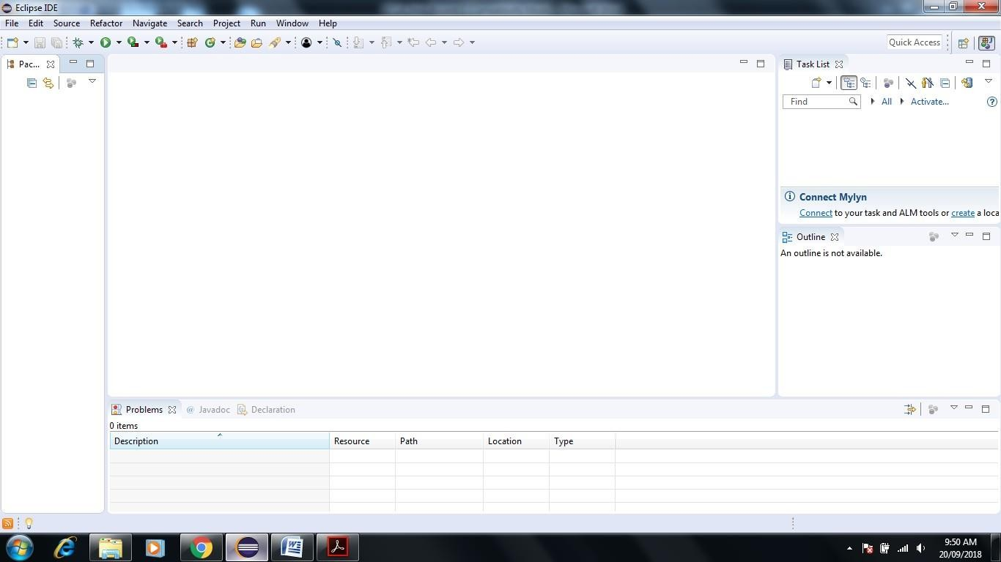**Open Eclipse IDE**
3. **Go to File and Select New -> Create New Java Project**

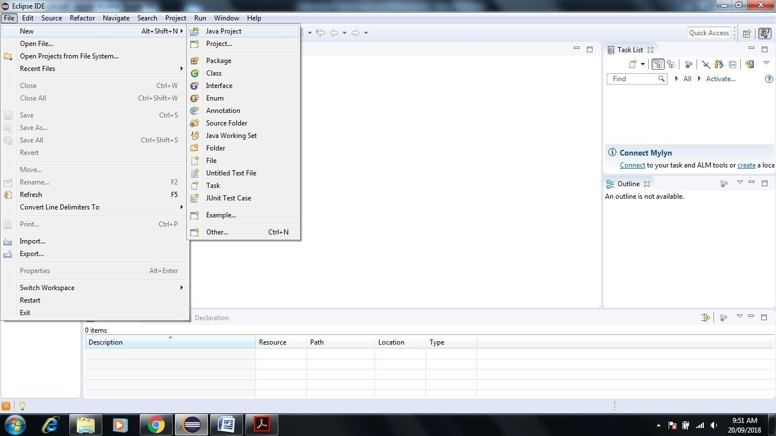

1. **Give JunitTestProject name to the project and check use project folder as root for source and class files**

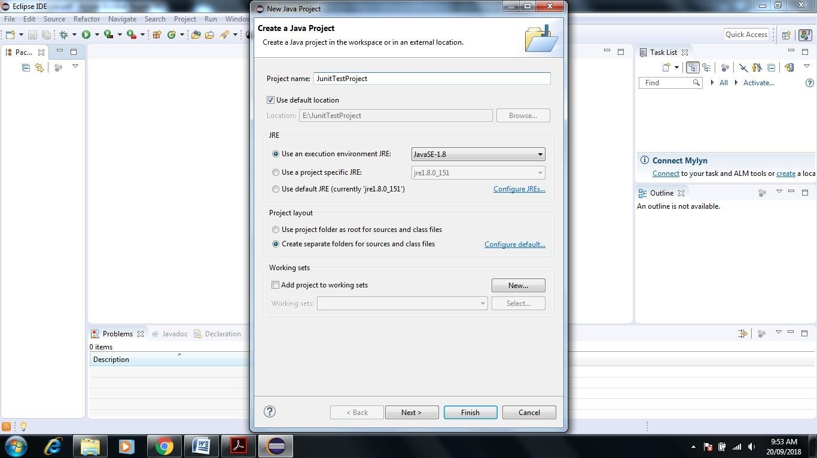

1. **Click on Next-> Next Screen will Appear-> Click Finish**

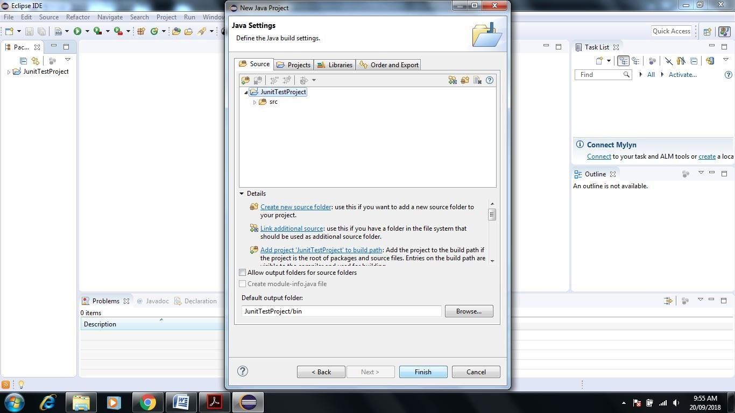

1. 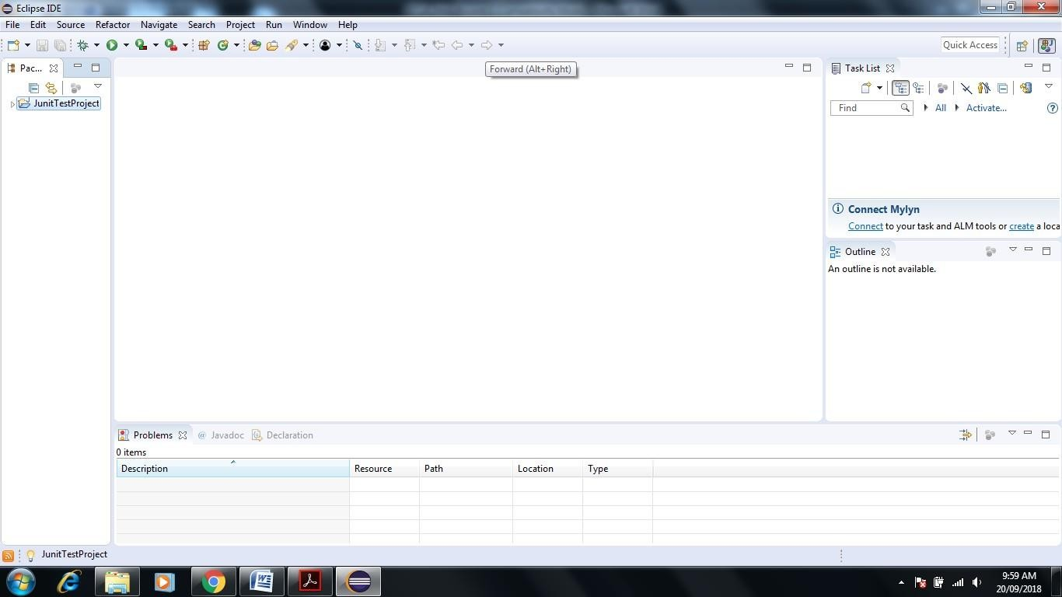**Next Screen Shown JunitTestProject Folder in Project Explorer**
2. **Right Click on Folder name JunitTestProject->New->Package**

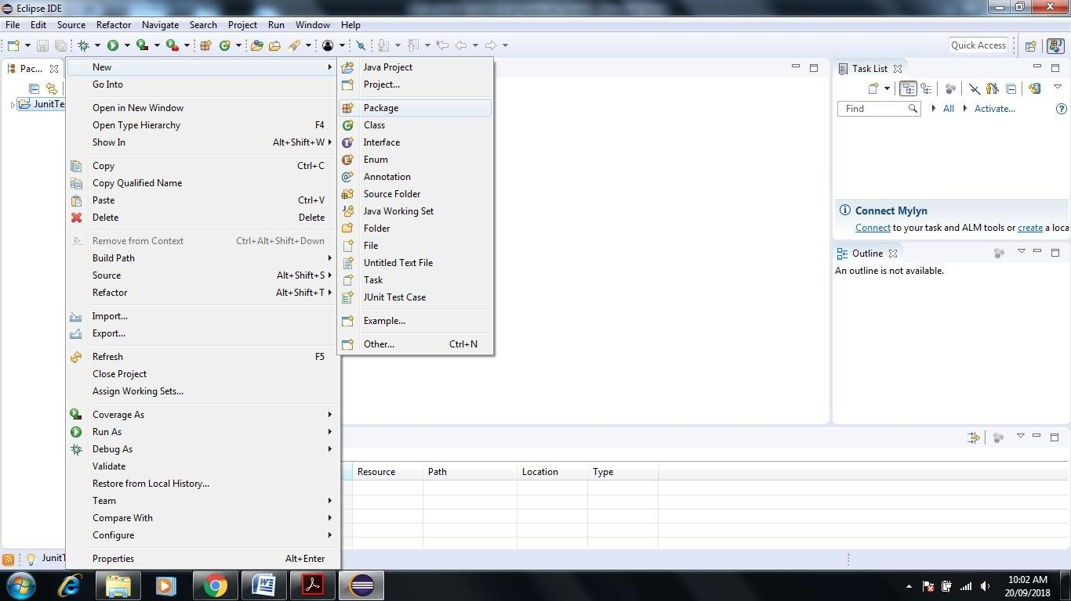

1. 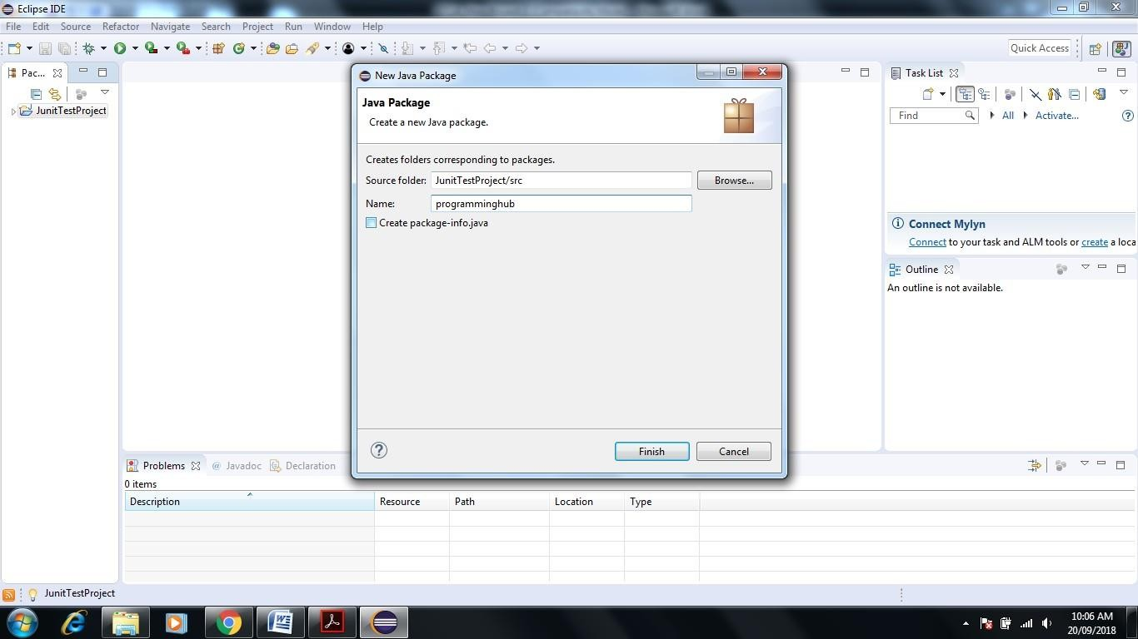**Name package as programming hub-> Click on Finish**
2. **See the Programming hub package see in project Explorer Screen of Eclipse**

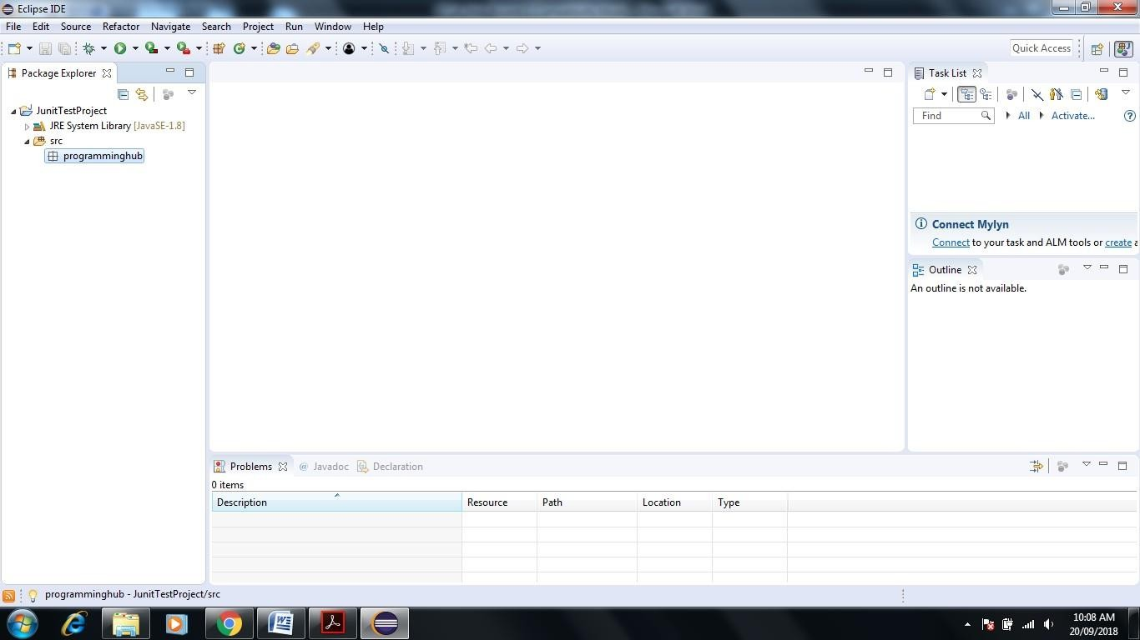

1. 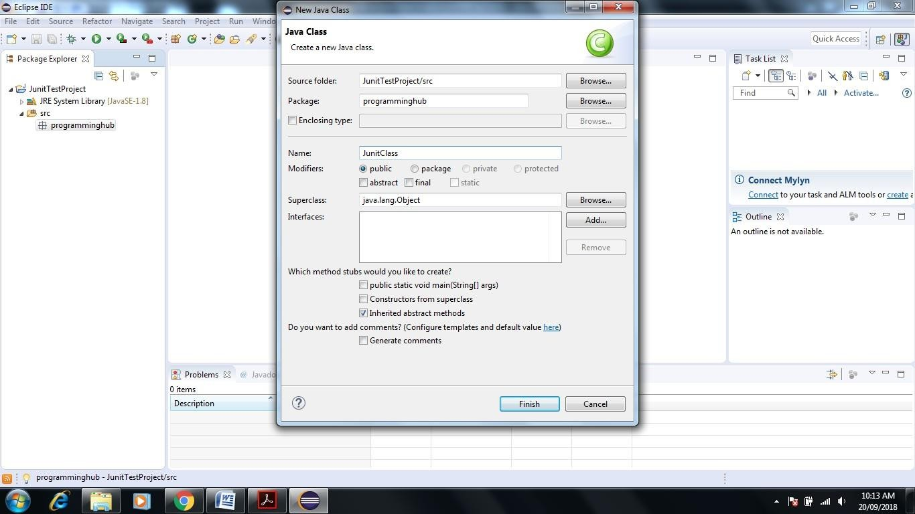**Right Click on Programminghub Package->New->Class give the name JunitClass->Click Finish.**
2. **Next screen will appear**

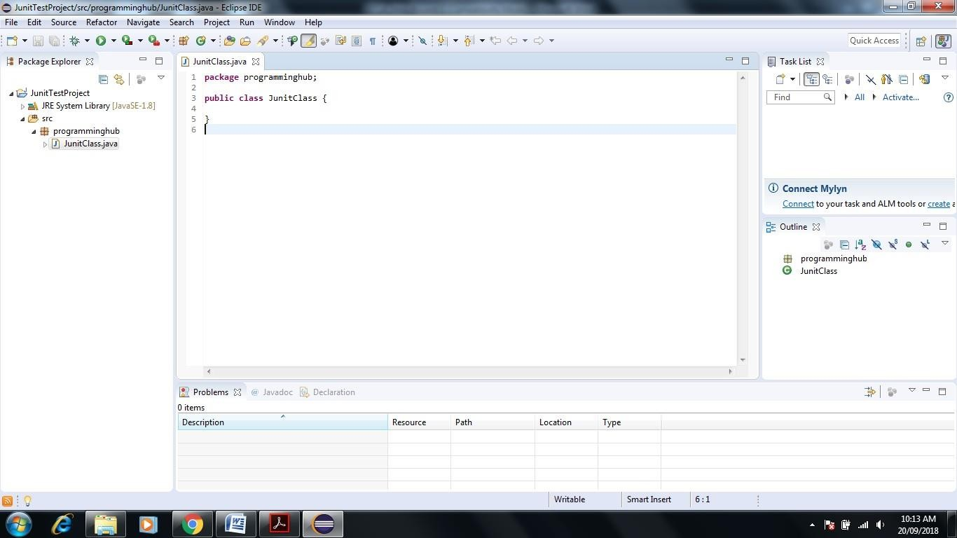

**12 Write a small program with only two functions Add and Multiplication**

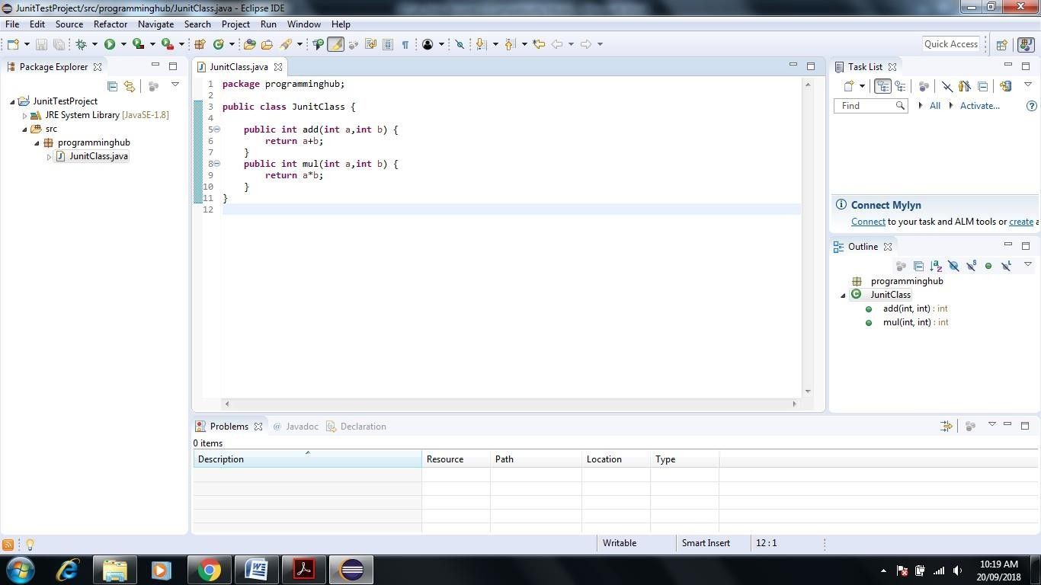

1. **Write Test Cases for Java Program**

**Right click on Junitclass-> New-> Click on Junit Test Cases**

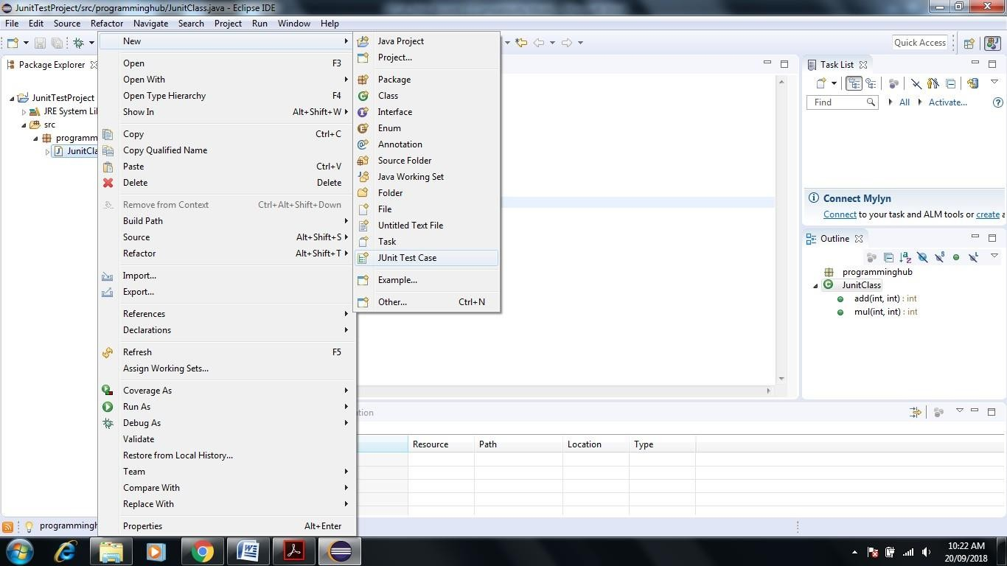

1. **Name test suite as AddTest and choose New Junit4 test**

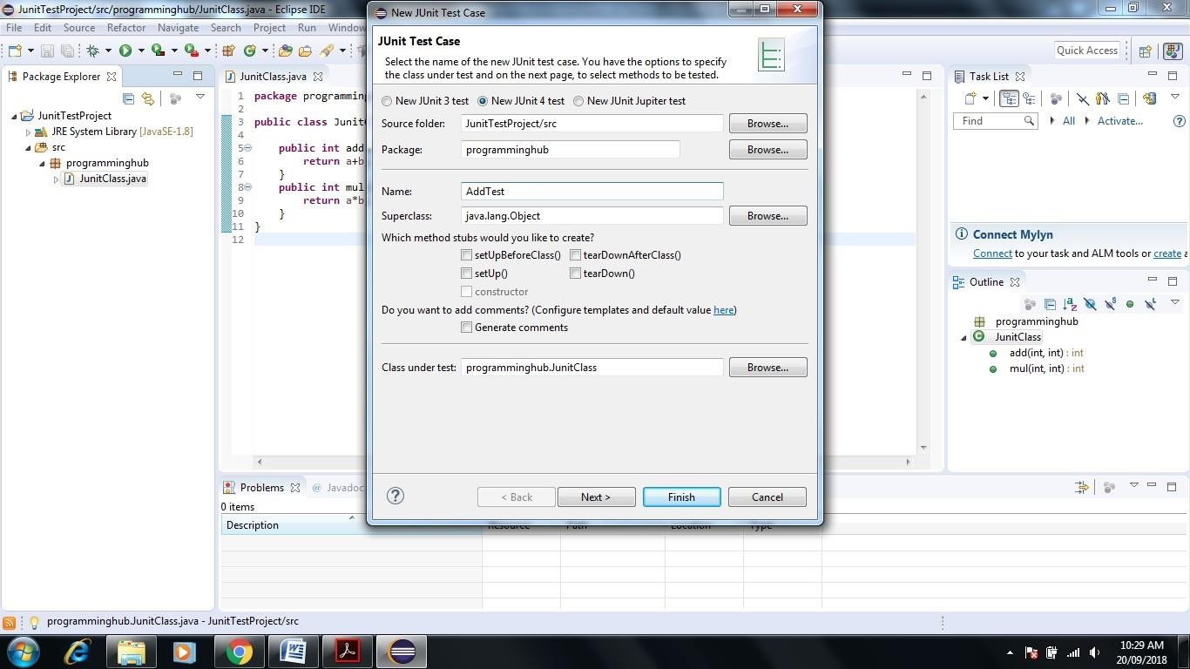

1. **Click on add Checkbox**

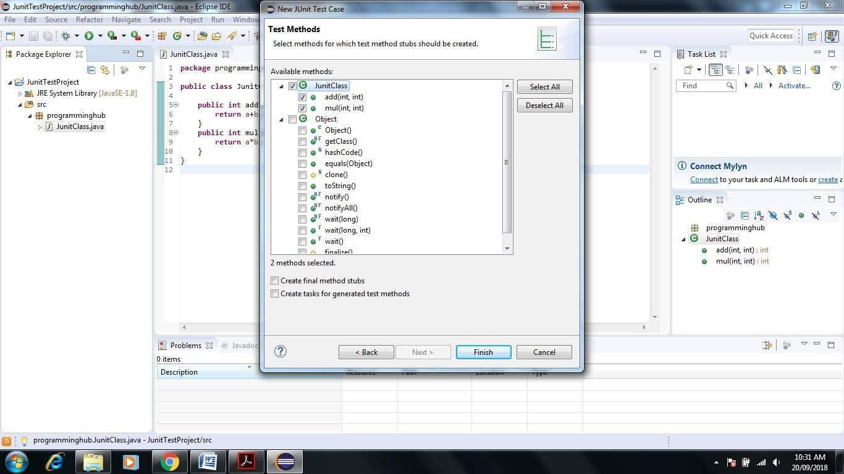

1. **Click on Next-> Ok**

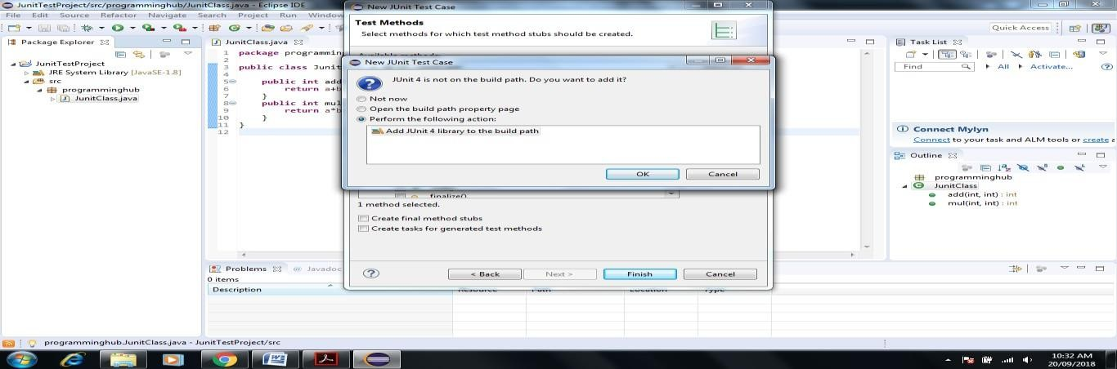

1. 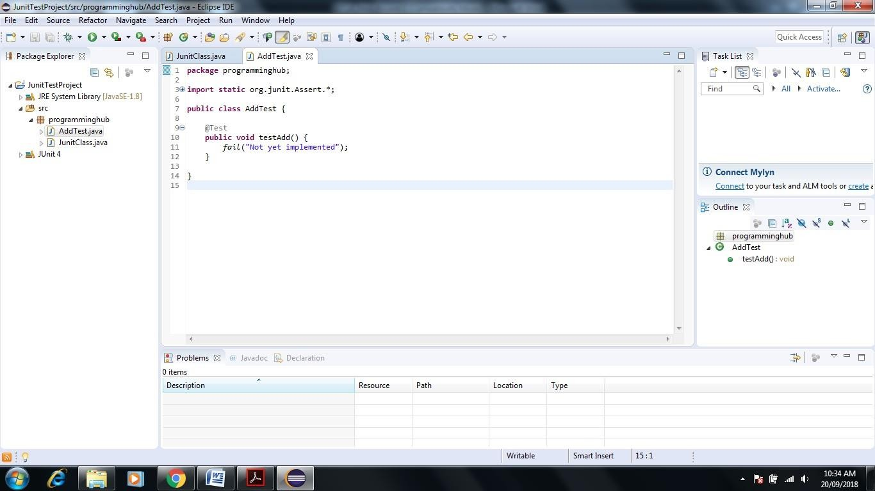**Next screen will appear**
2. **Write a code for Test case addition of two number inside AddTest**

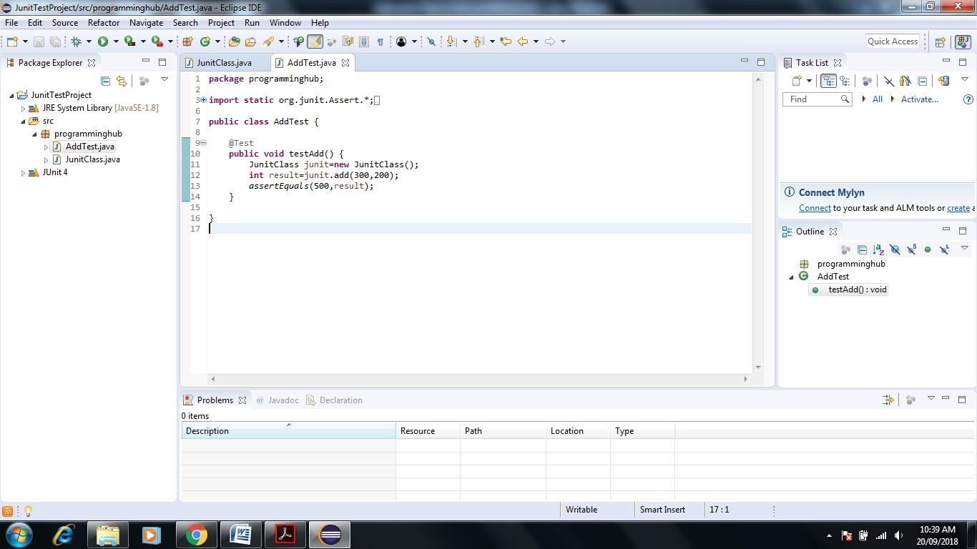

1. **Let us run AddTest test case. Right click AddTest-> Debug As->JUnit Test**

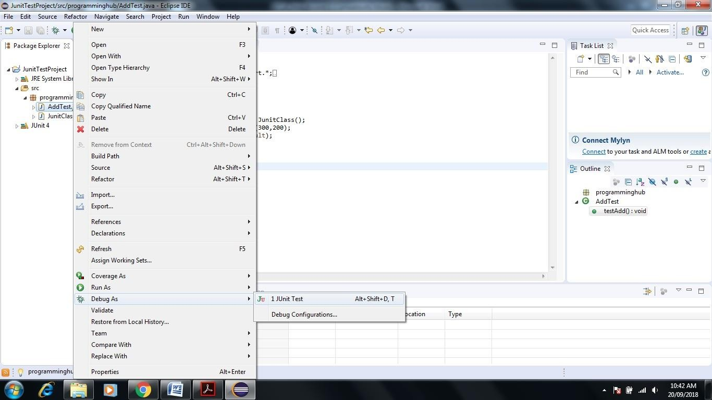

1. **Result of test case is as follows. It shows 0 error and 0 failure and green color test bar which means that test case has run successfully( Green Color Bar Indicate)**

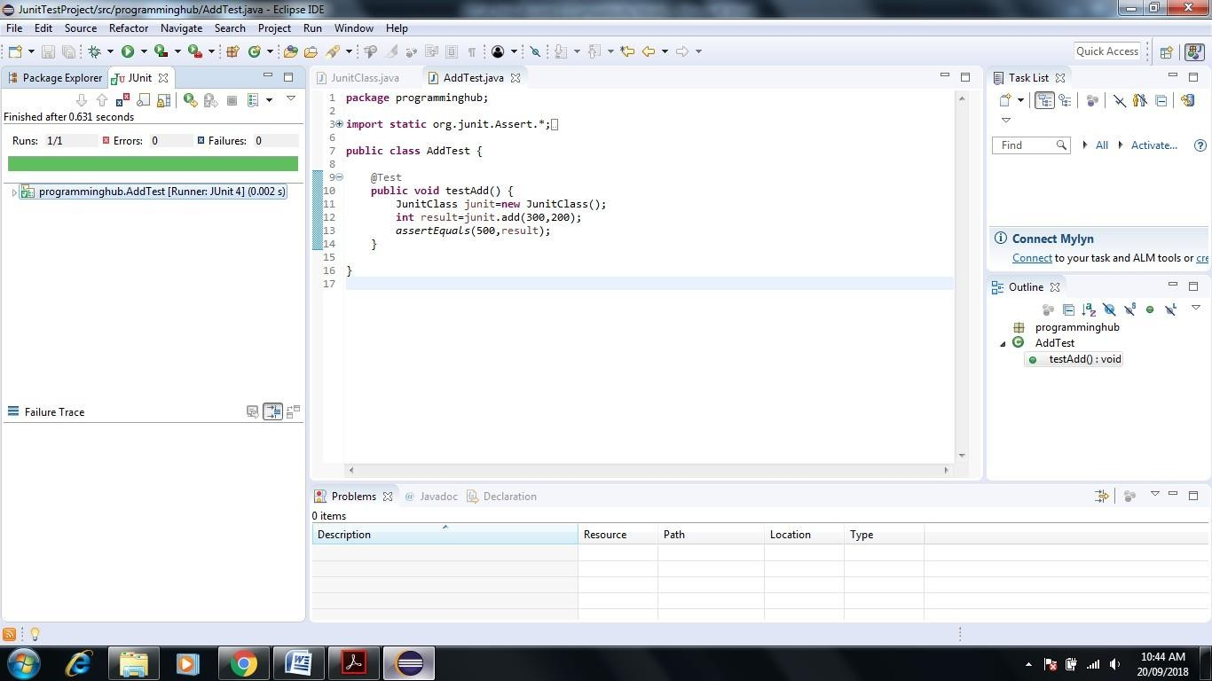

1. **Let us purposely give wrong input in assertEquals method or unexpected result here we write 501 instead of 500 indicate wrong addition result**

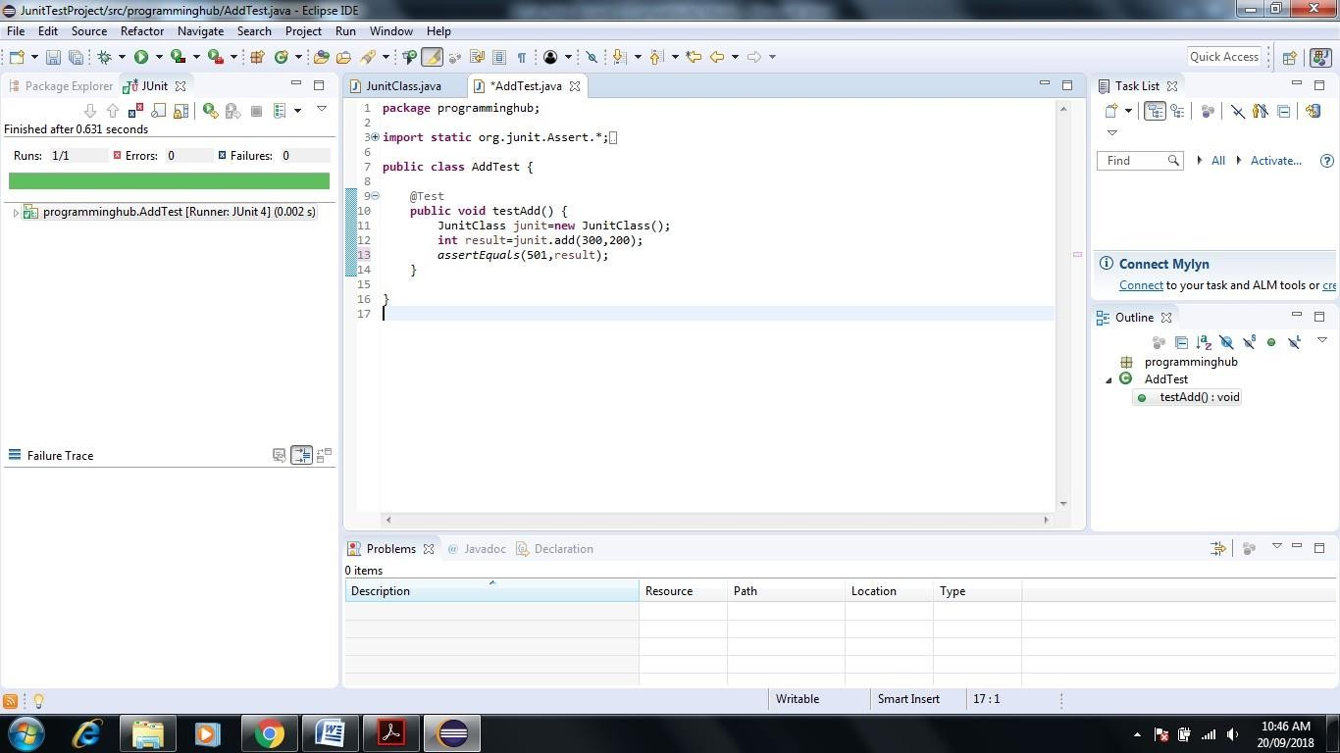

1. **Now test case should fail.(Brown Color Bar Indicate) So again run AddTest as follows**

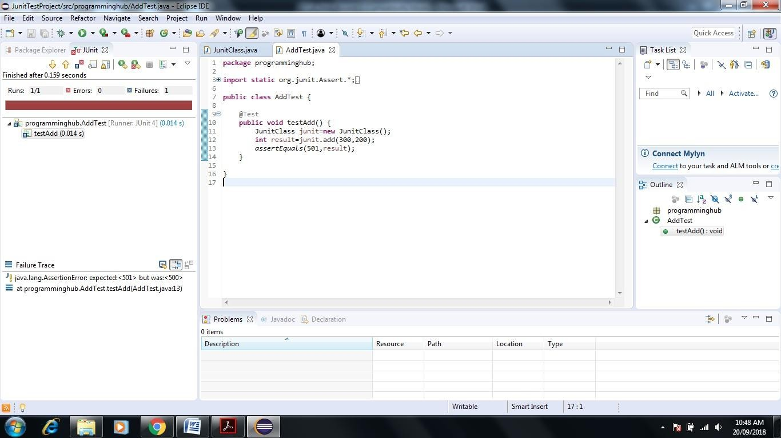

1. **Similarly you can Create Test case for Multiplication Function**

**Click on Project Explorer Screen-> Right Click on JunitClass->New->JUnit Test Case-> Give name MulTest.**

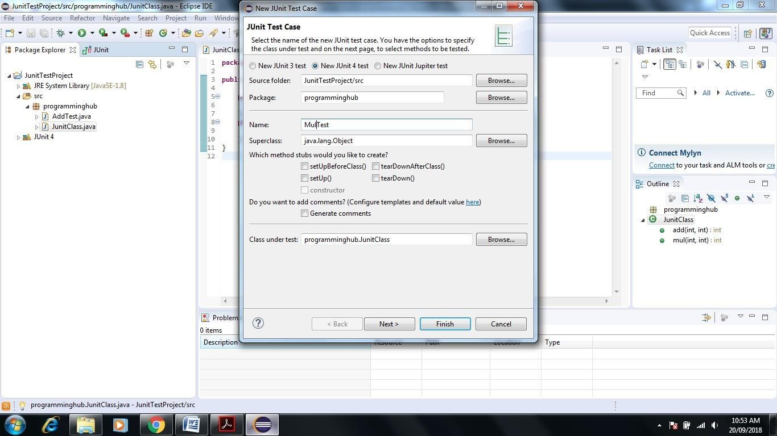

1. **Click on Next ->Select Mul Check Box -> Click Finish**

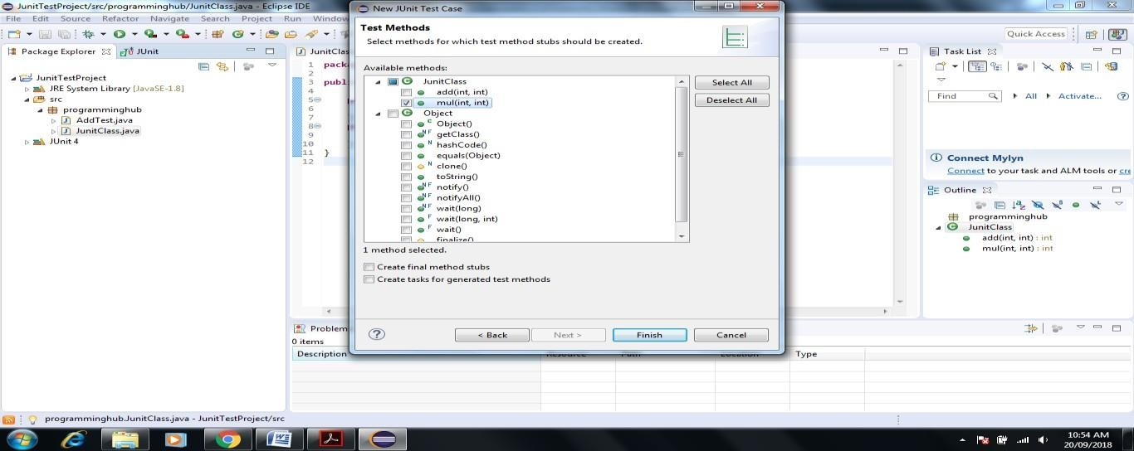

1. 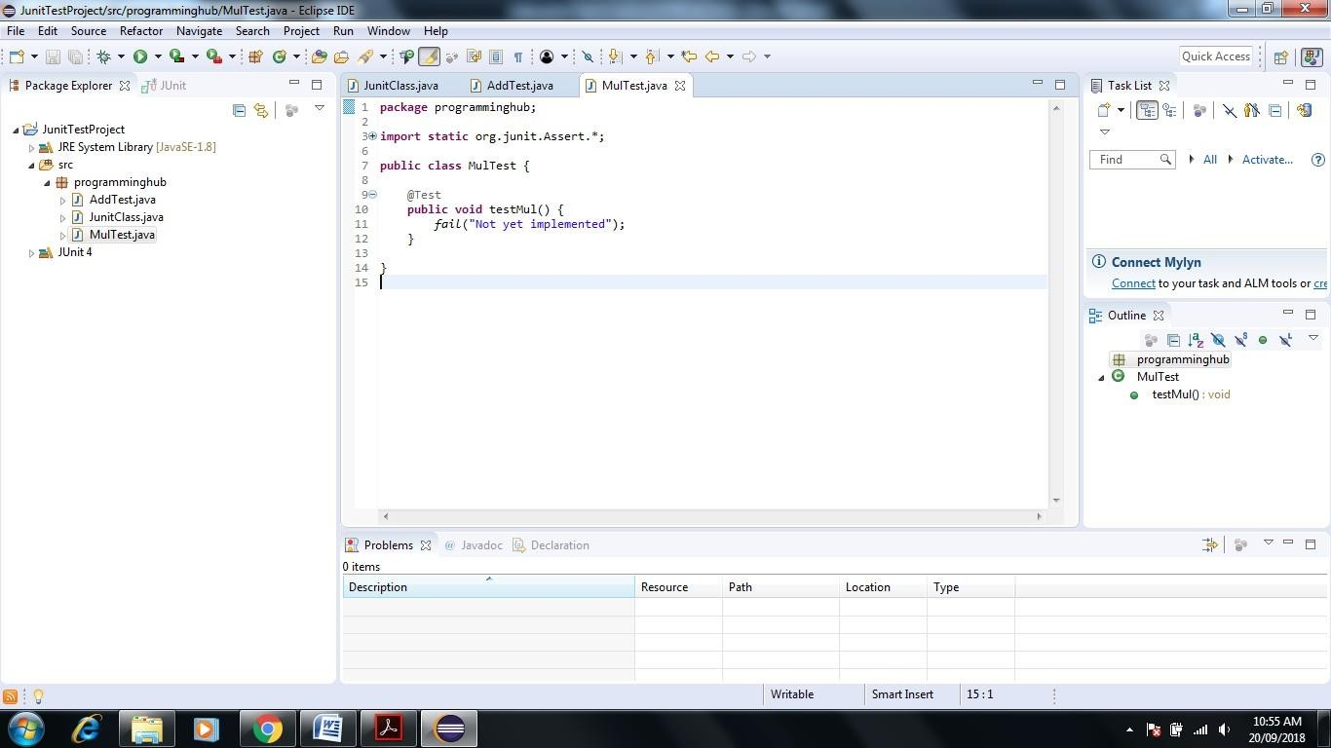**Next Screen will appear**
2. 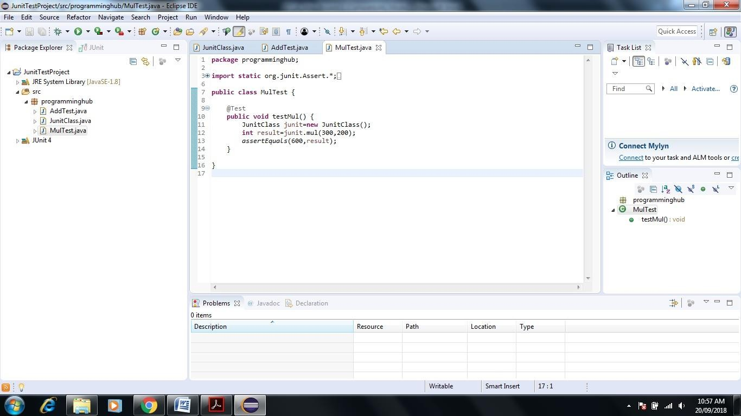**Write a Test Case Code inside MulTest method**
3. 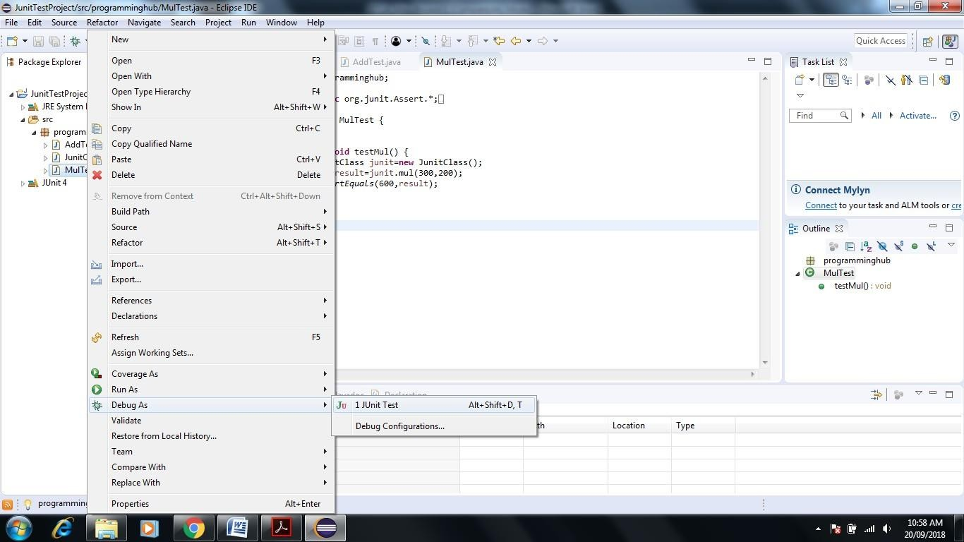**Right Click on MulTest->Debug->JUnit Test**
4. 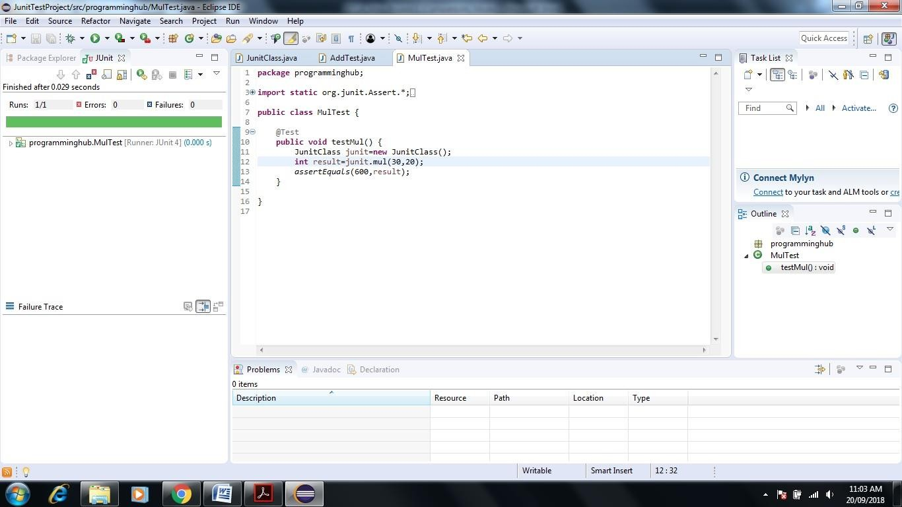**Execute Test**

**Test Suite – it is used to test multiple test cases at one time.**

1. **Now let us create Test Suite both add and mul test cases in one time**

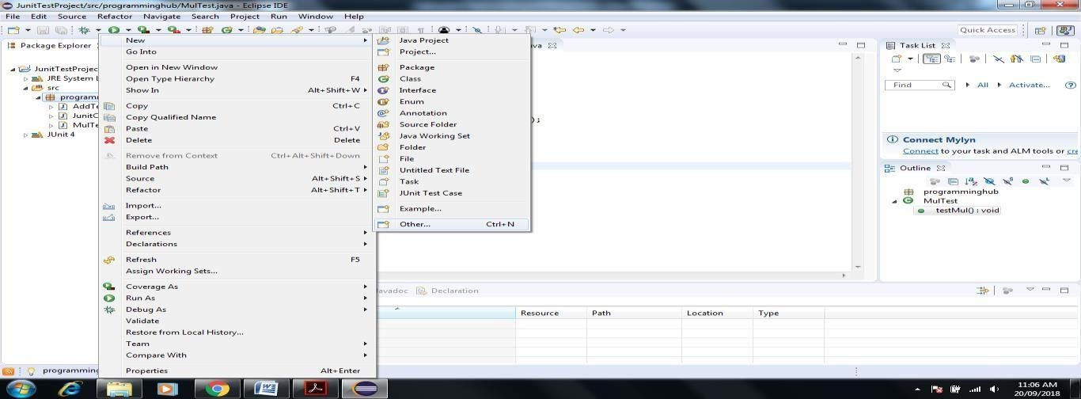

1. 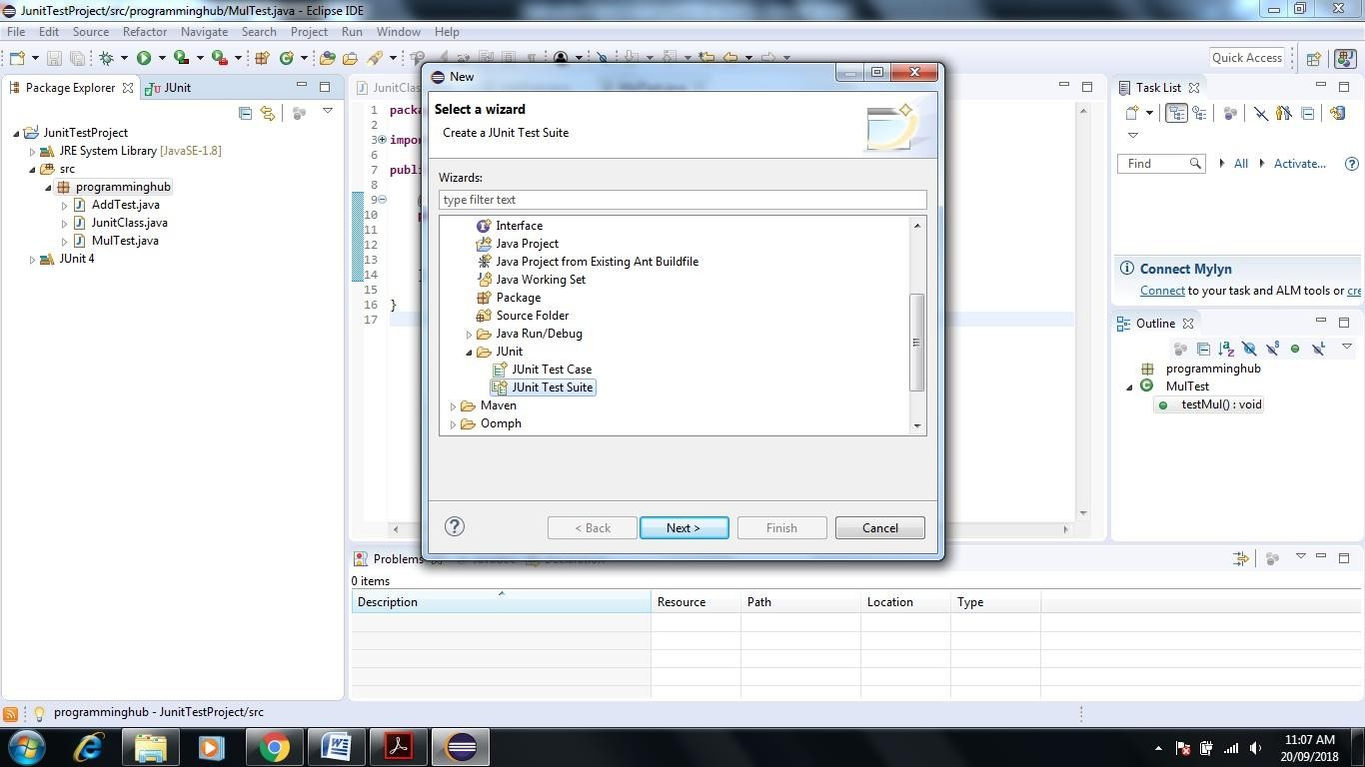**Click on Package name->New->Other->JUnit->JUnit Test Suite->Next**
2. **Click on Finsh**

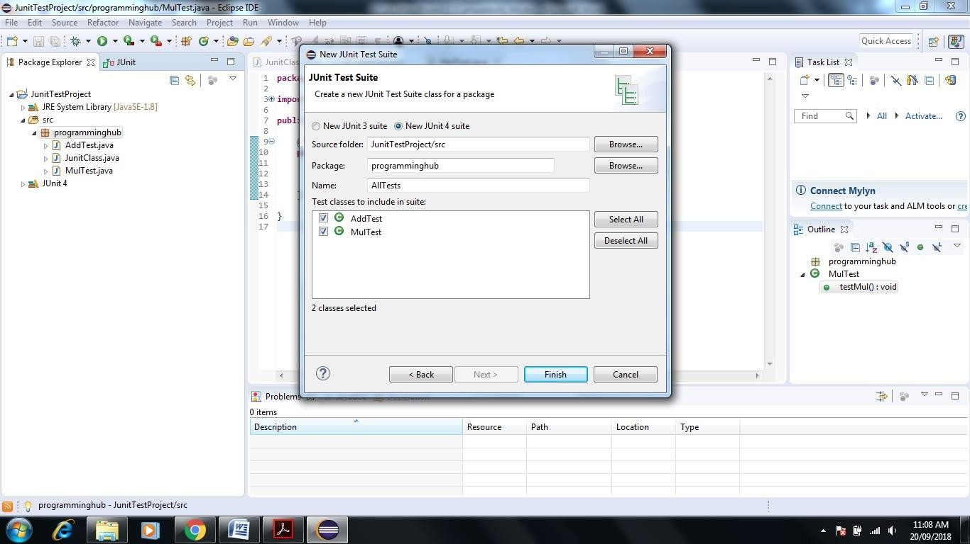

1. 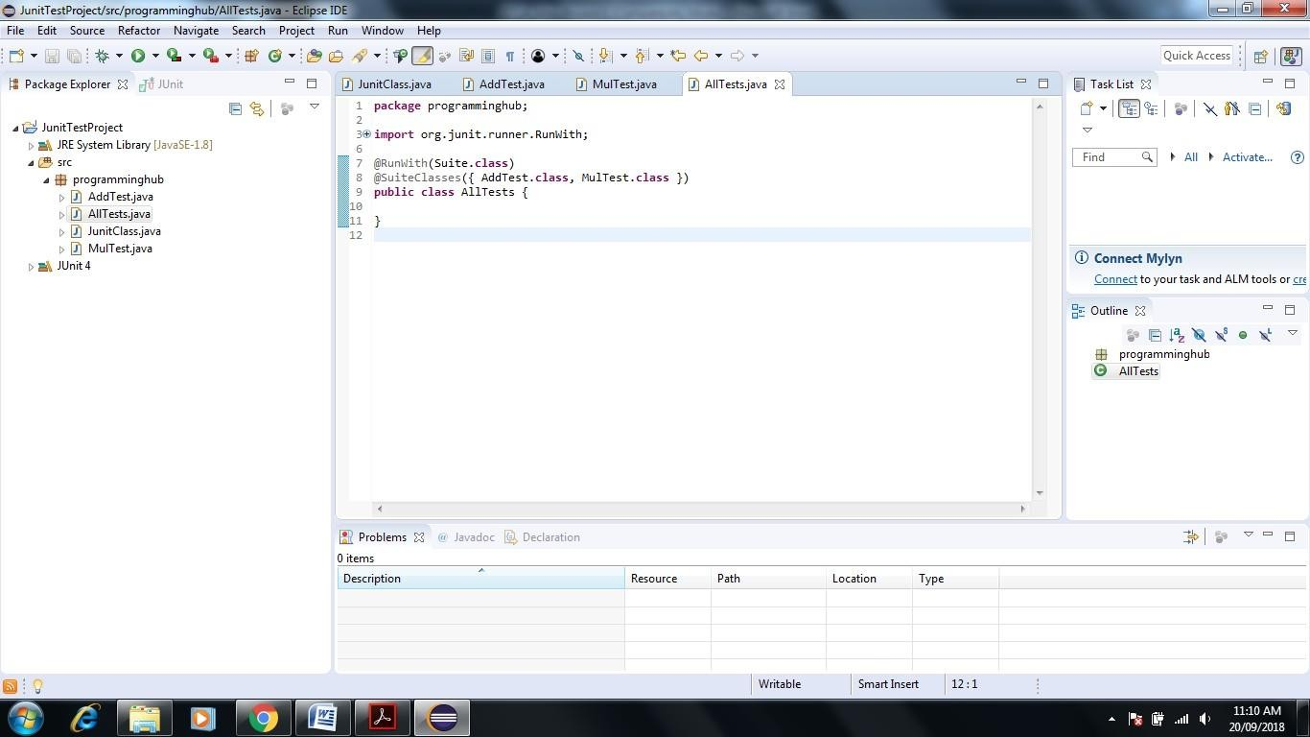**Next Screen Appear that automatically create Test Suite for Add and Mul**
2. 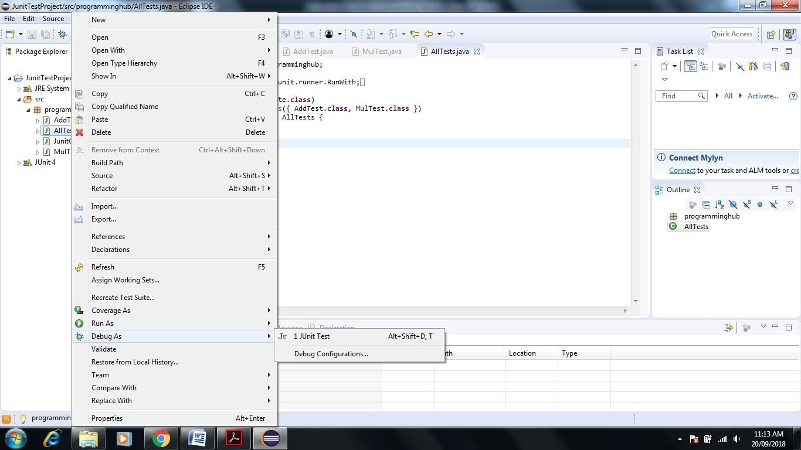**Execute Test Suite Right Click on All Test ->Debug->JUnit Test**
3. **Test Suite Executed successfully Test suite fails even if a single test case among all fails.**

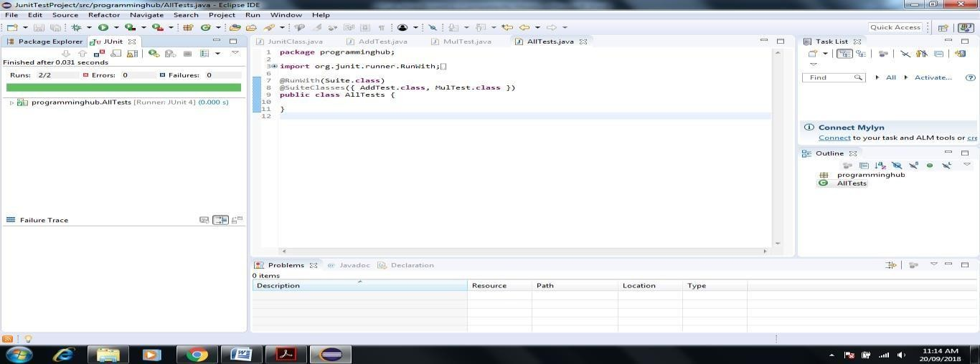

1. Now Create **Test Report** Using **Apache Maven**

***If you use eclipse-java-photon-R-win32 Version it include Maven in built installed so no need to install software via Eclipse help Install Software Option***

## Click on Help in Eclipse->Eclipse Marketplace->Enter Maven Keyword in Search box->Select Maven Integration version as per requirement->Click on Install

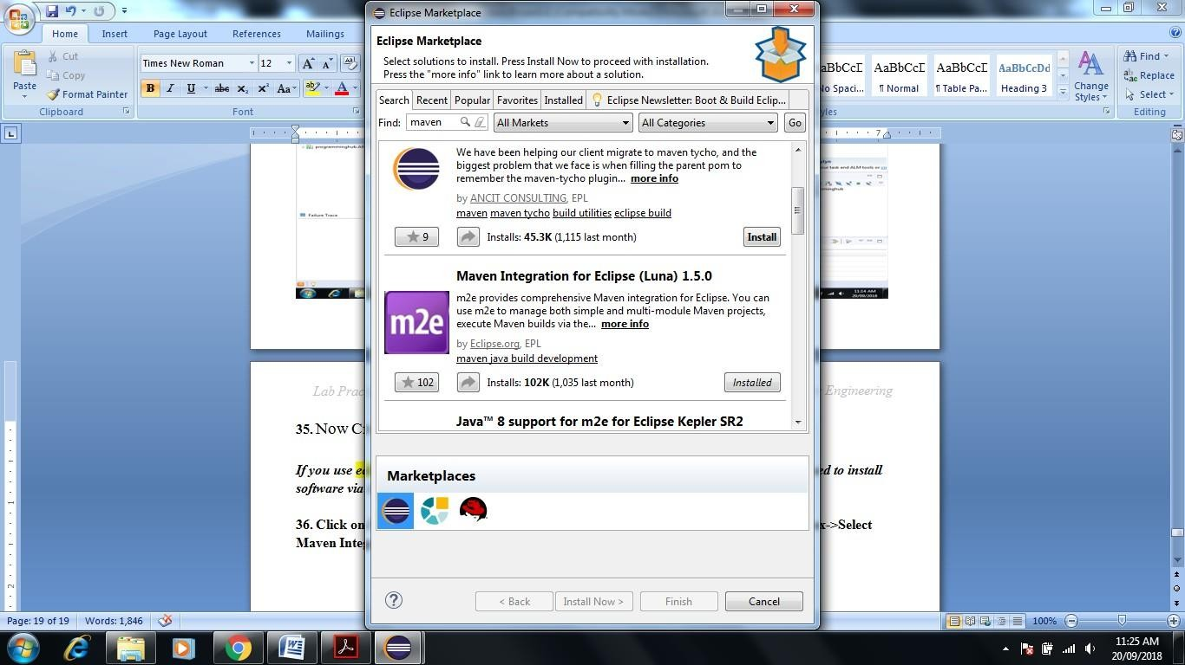

1. 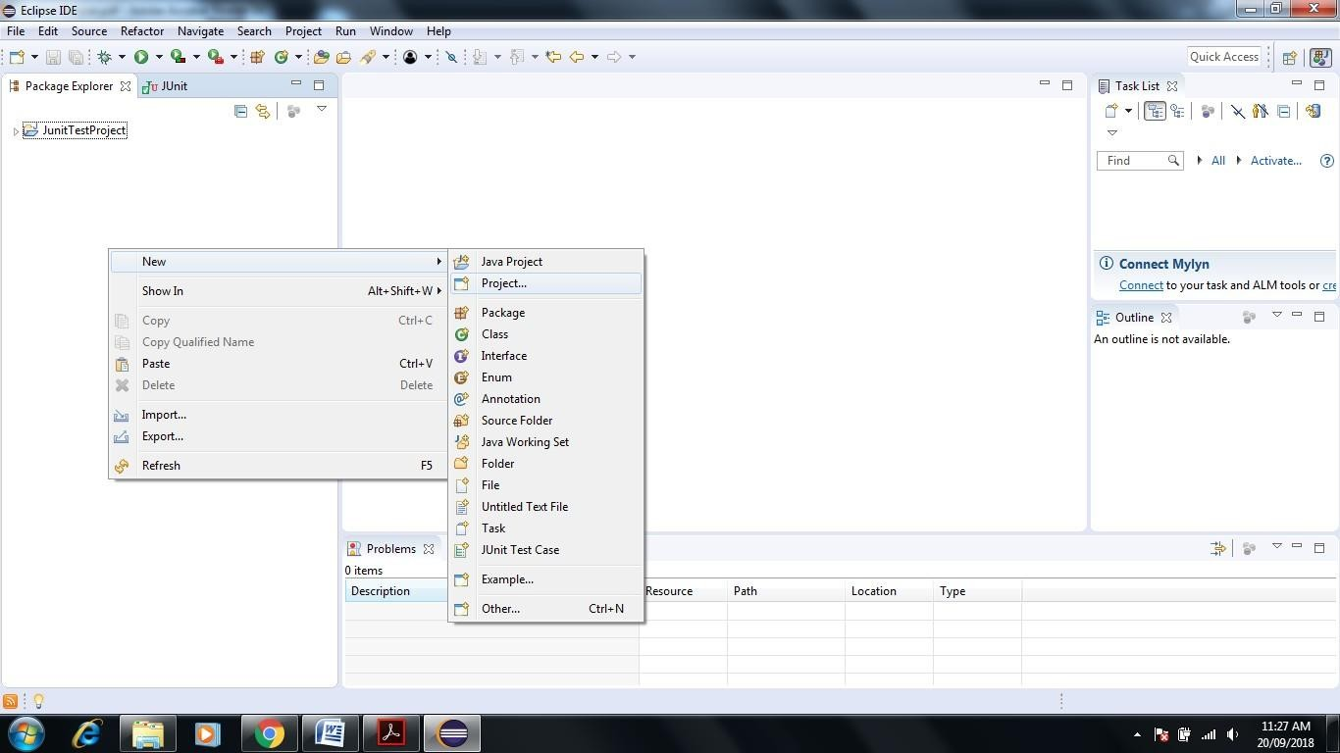**Right Click in Project Explorer Window**
2. 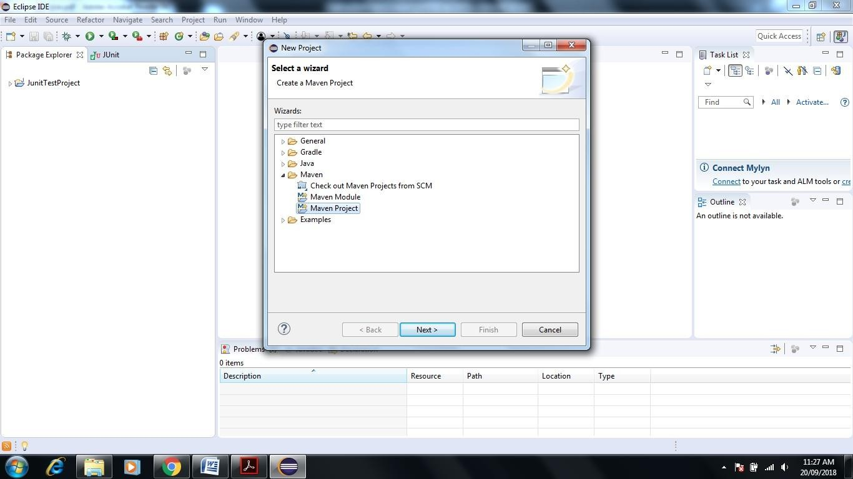**Go to Maven Project-> Click Next**
3. 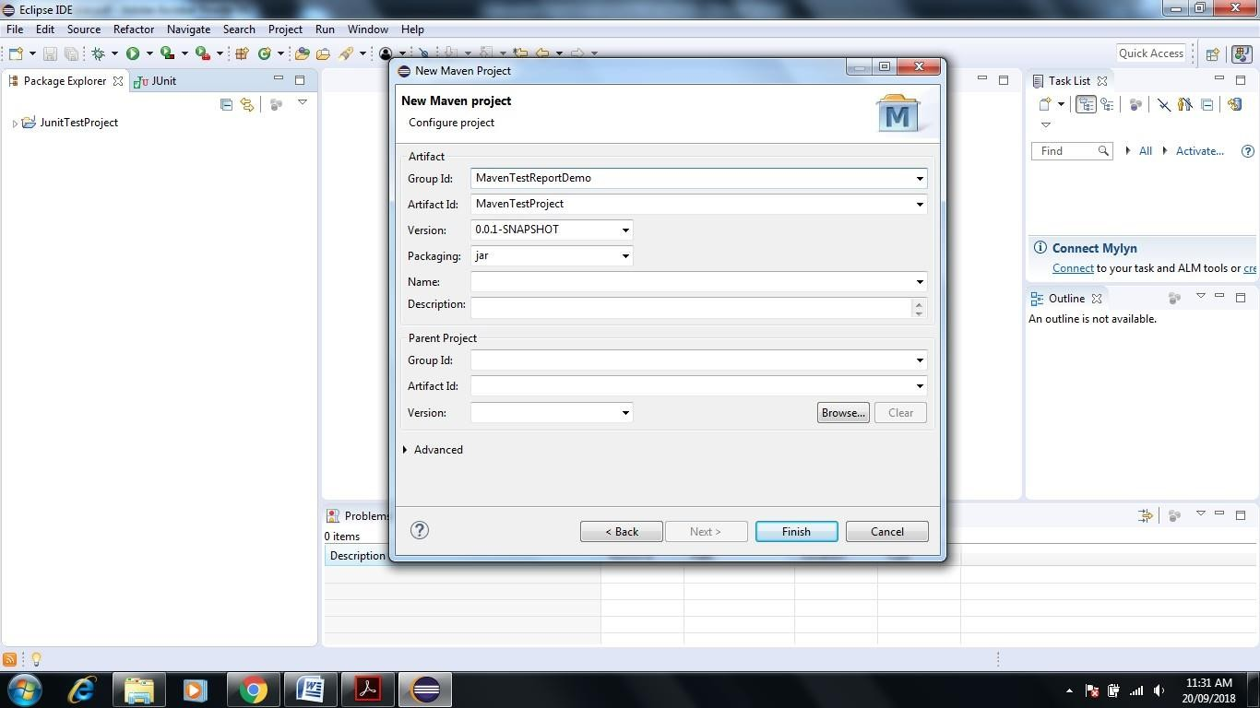**Select Check Box Create Simple Project-> Click Next-> Give Group Id and Artifact name**
4. **Click on Finish-> Next Screen Appear**

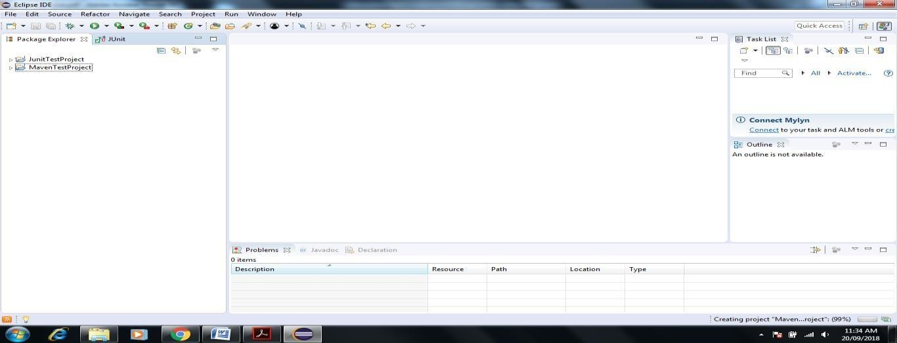

1. 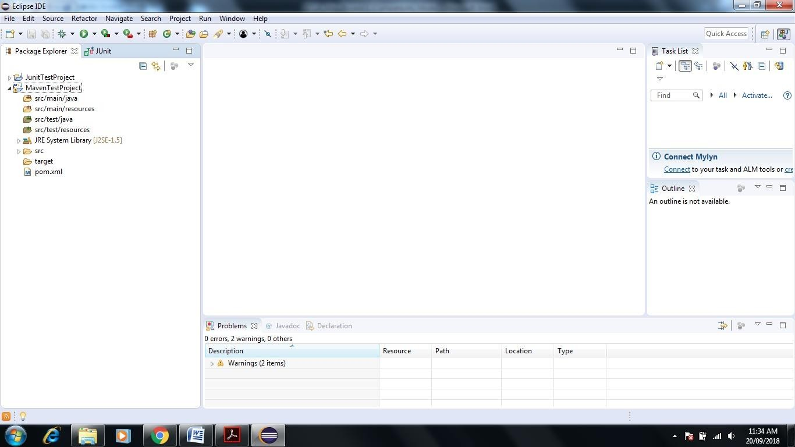**MavenTestProject shown Pom.xml file doble click on same**
2. **it shown some description like**

<modelVersion>4.0.0</modelVersion>

<groupId>MavenTestReportDemo</groupId>

<artifactId>MavenTestProject</artifactId>

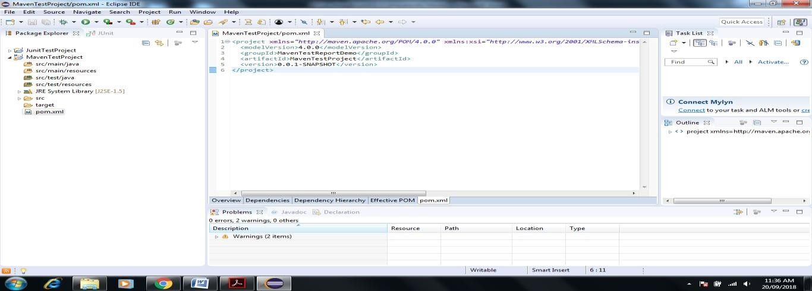<version>0.0.1-SNAPSHOT</version>

## We add dependencies to pom.xml of Junit and Selenium

1. **To add dependency** **Go to Google.com->Enter Maven repository-> in Search box on SiteEnter Junit**

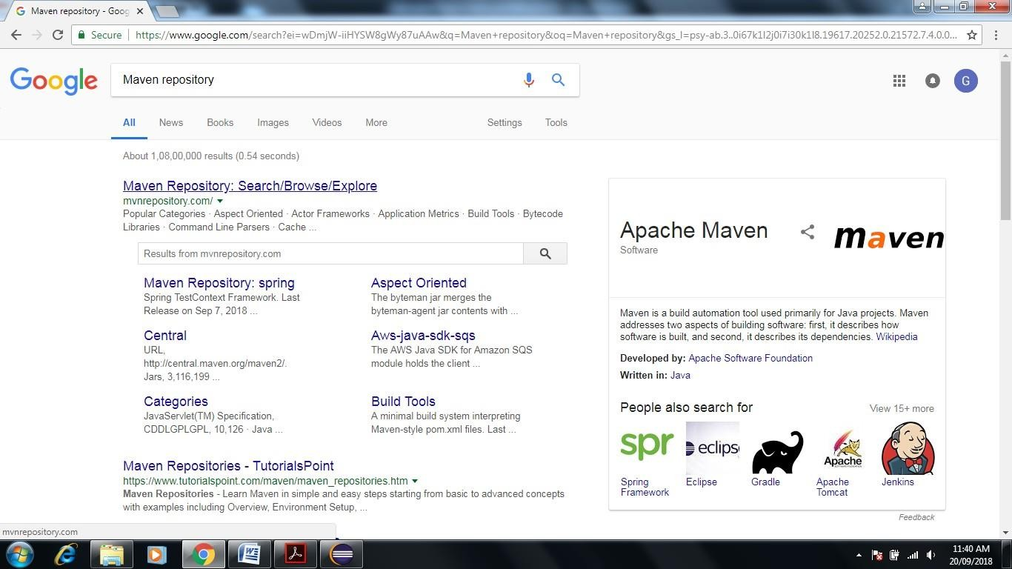

1. **after Enter keyword Junit inside Seach box then Enter->it shown another Site Maven Repository for Junit Select that site.**

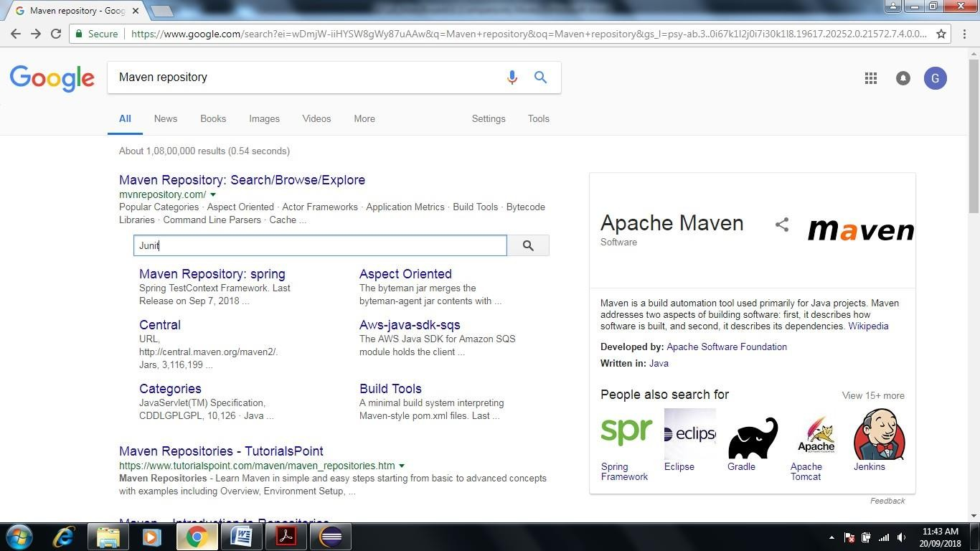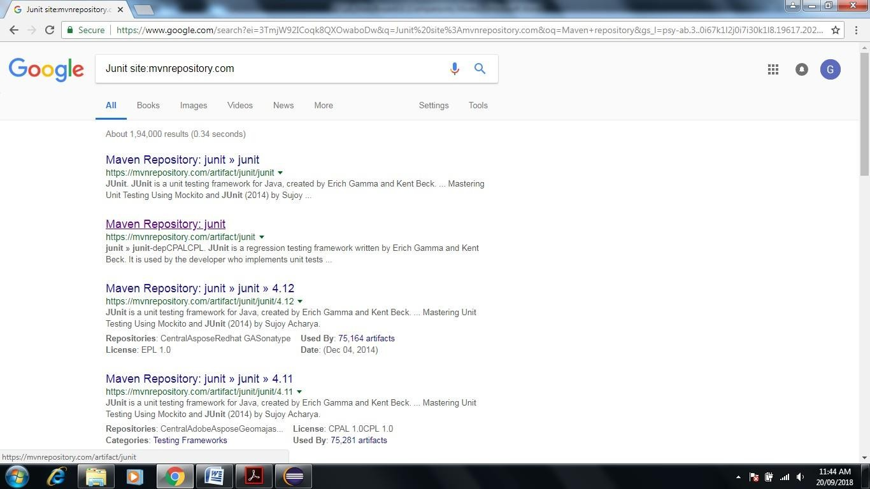

1. **Click on Maven Repository-JUnit it open another site-(<https://mvnrepository.com/artifact/junit>)**



1. **Click on JUnit-> Open and click on latest version as shown below (here 4.12x)**

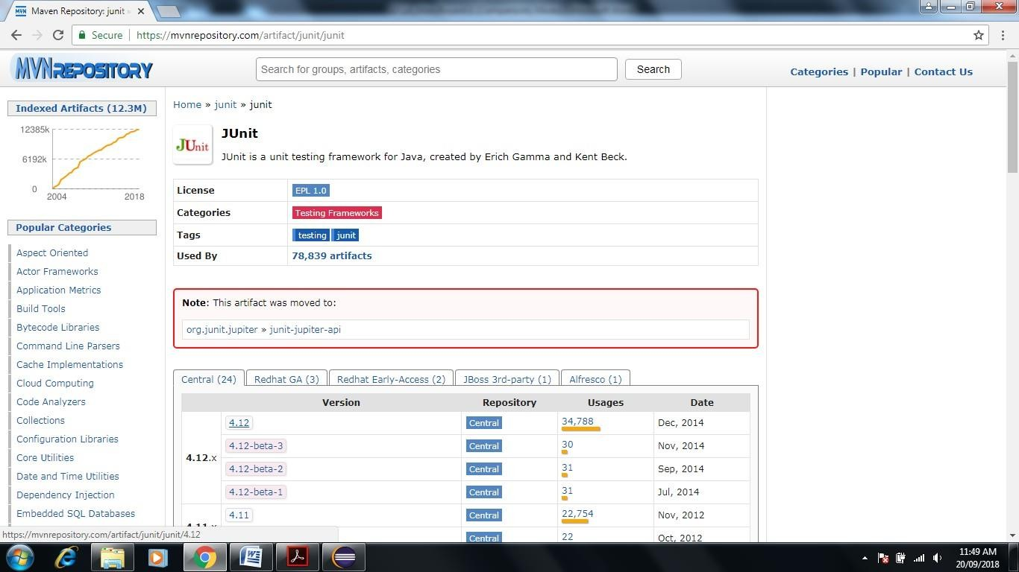

1. **Copy above dependency to paste in pom.xml in Maven in Eclipse**

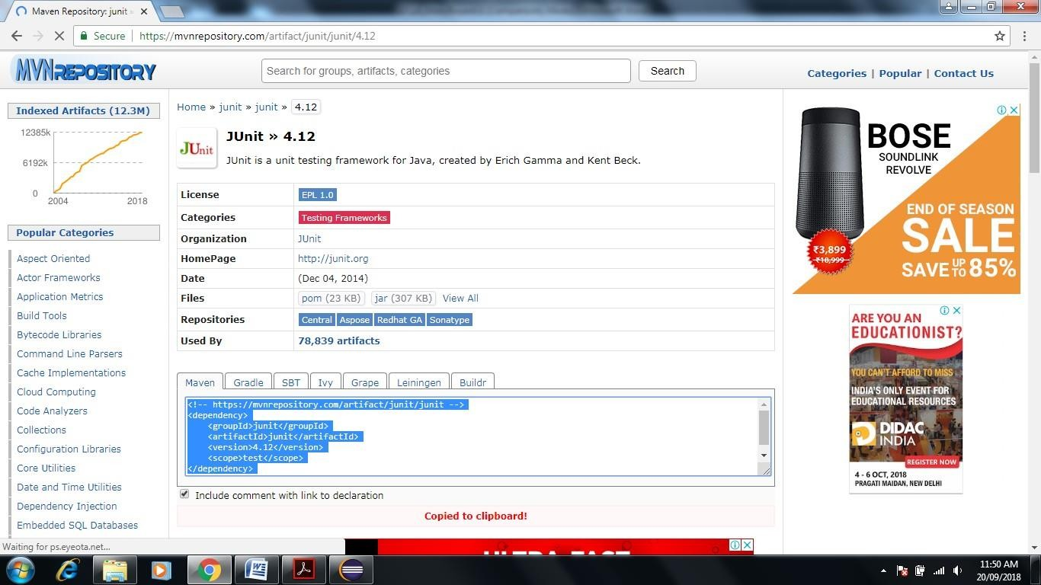

1. **Add <dependencies> tag before pasting as shown below**

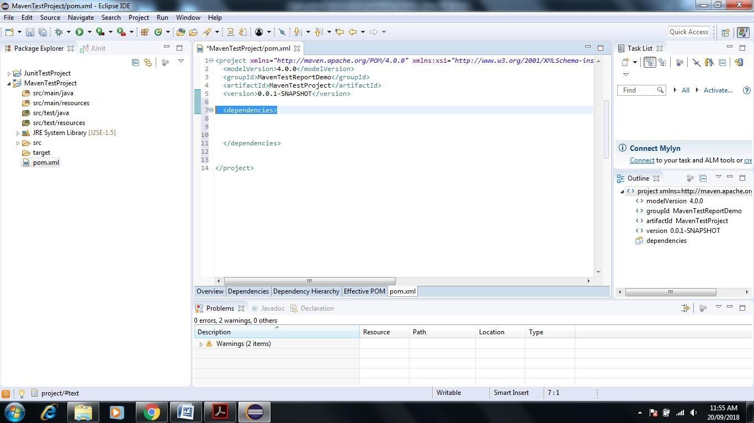

1. **Now Paste the above code in between <dependencies> tag then save pom.xml file**

<!-- https://mvnrepository.com/artifact/junit/junit -->

<dependency>

<groupId>junit</groupId>

<artifactId>junit</artifactId>

<version>4.12</version>

<scope>test</scope>

</dependency>

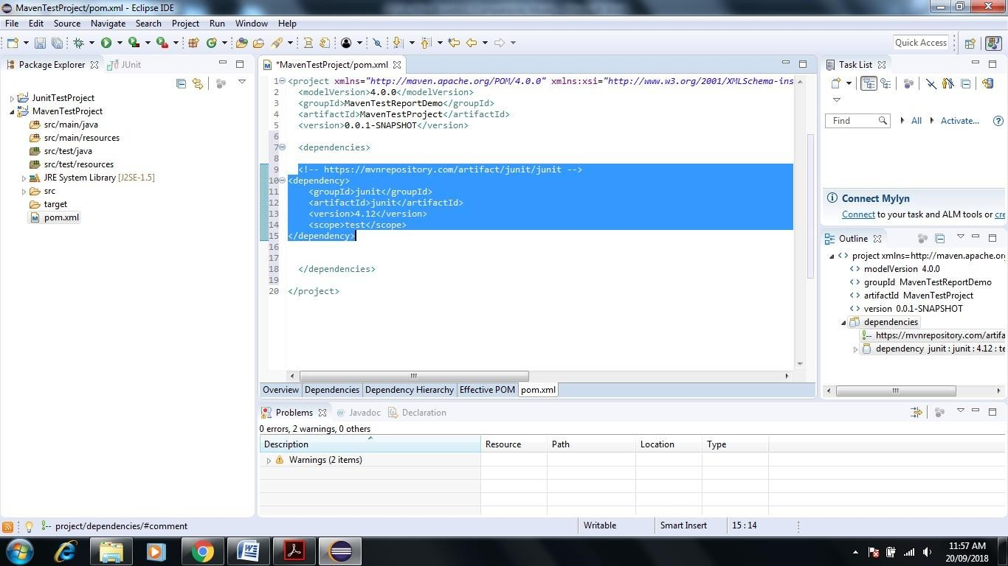

## Now it It gets reflected in Maven by adding Junit jars

1. **Same process can be repeated for Selenium server**

**Go to Google-> Enter Maven Repository->Enter Selenium Server in Search box->Enter**

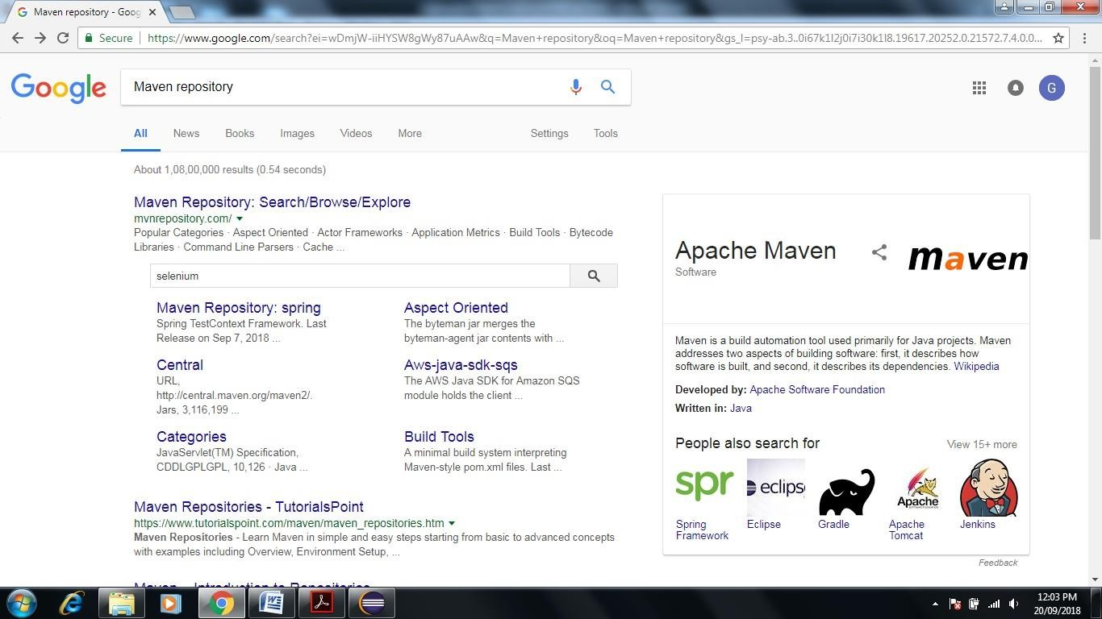

1. 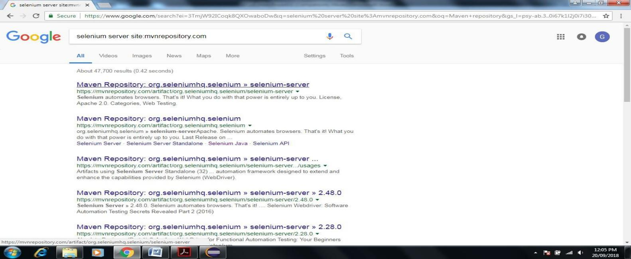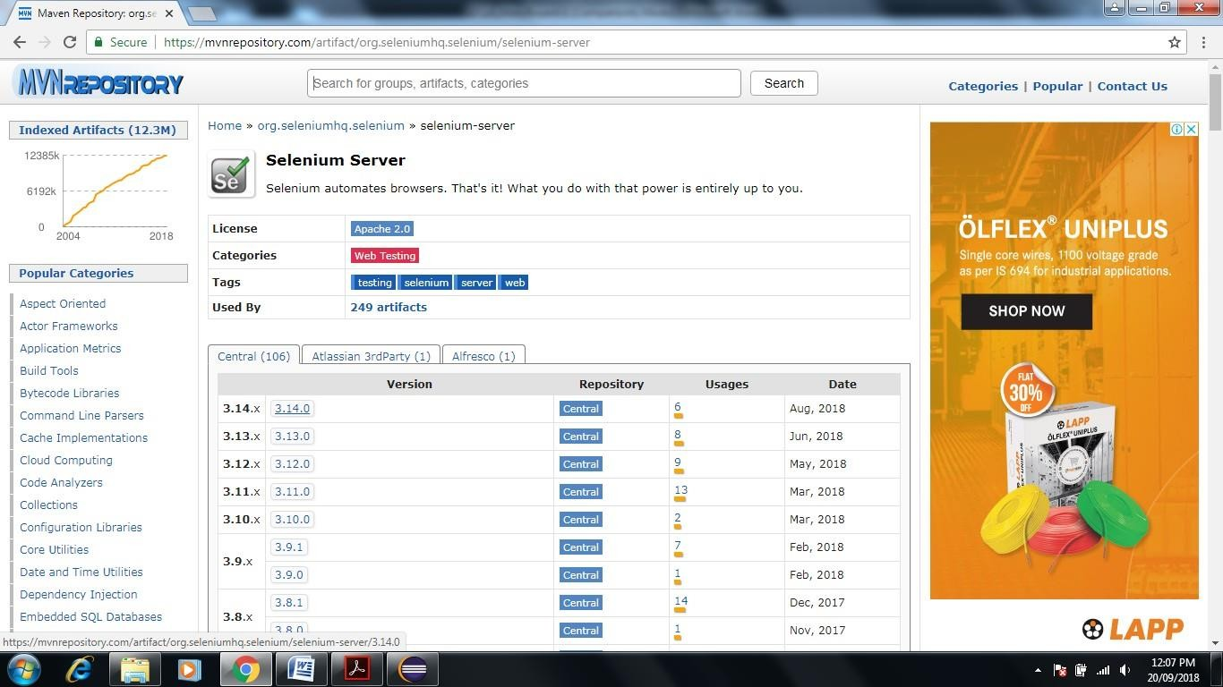**Click on First Link of Website-> Click on latest version**
2. 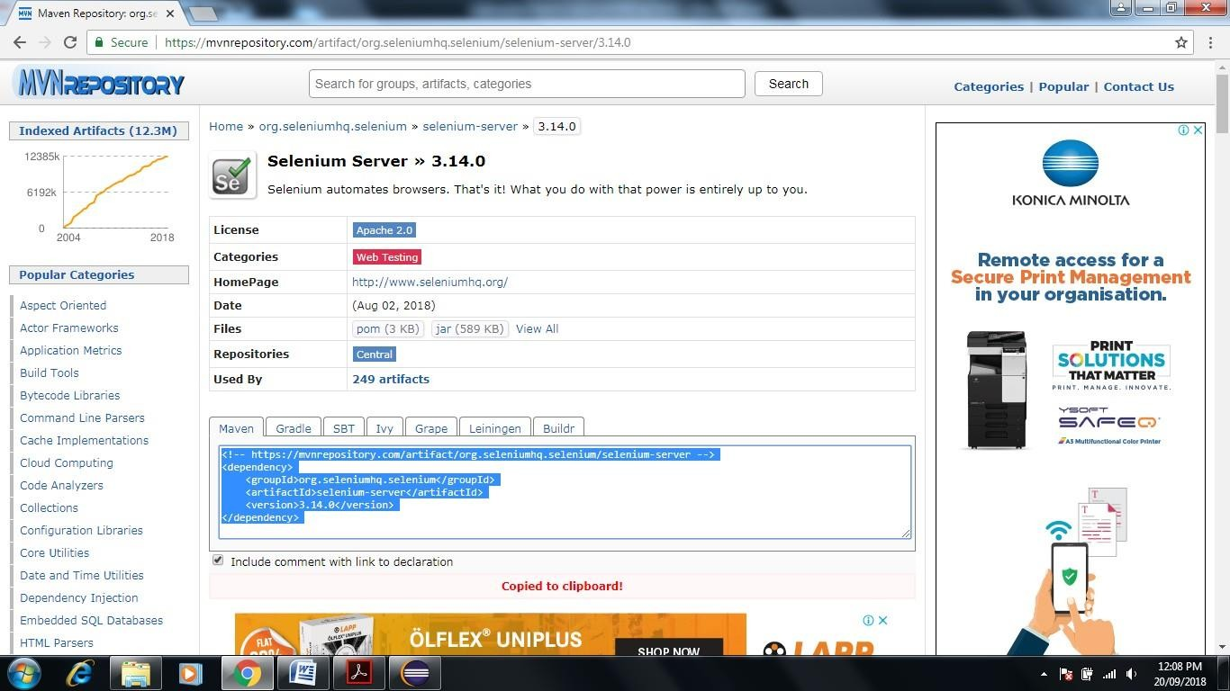**Copy Code in Maven Tab**
3. **Paste in pom.xml file in between <dependencies> tag**

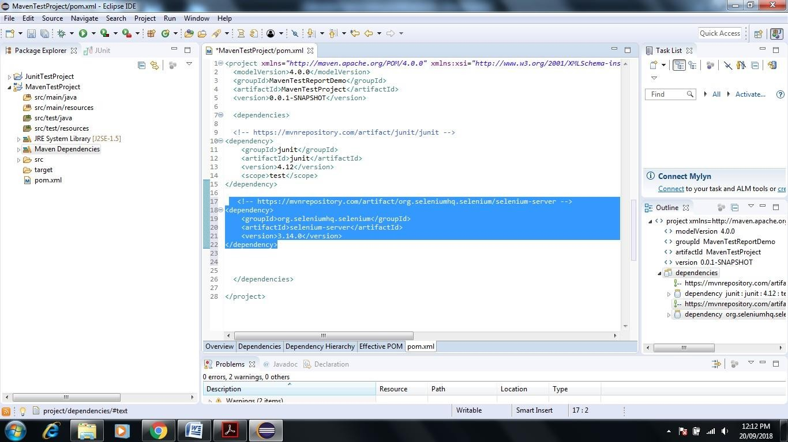

1. **Now Go to C:\Users\admin\.m2\repository\org\seleniumhq\selenium\selenium-server\3.14.0 Check the latest selenium server version.**

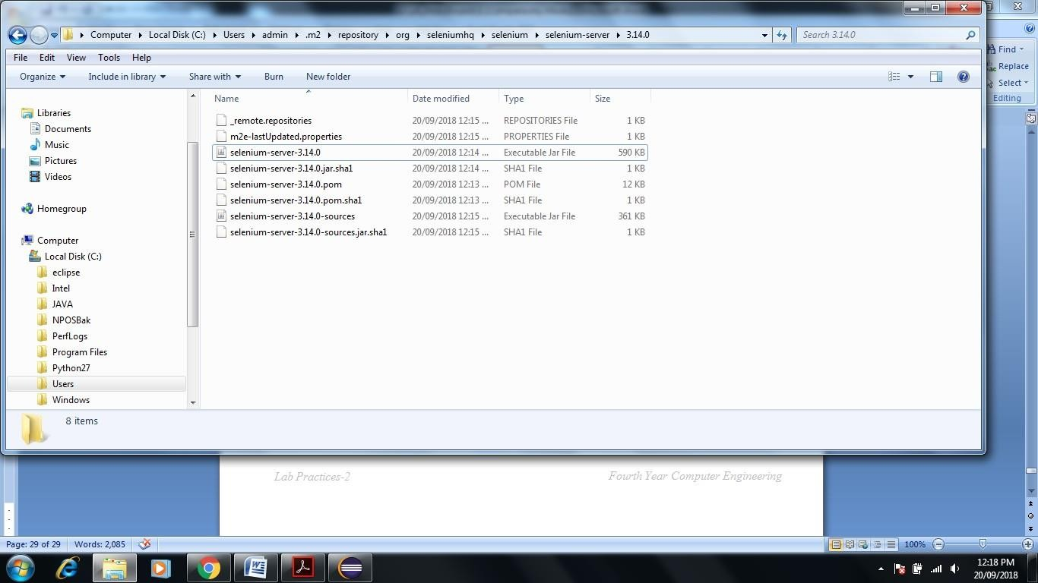

1. 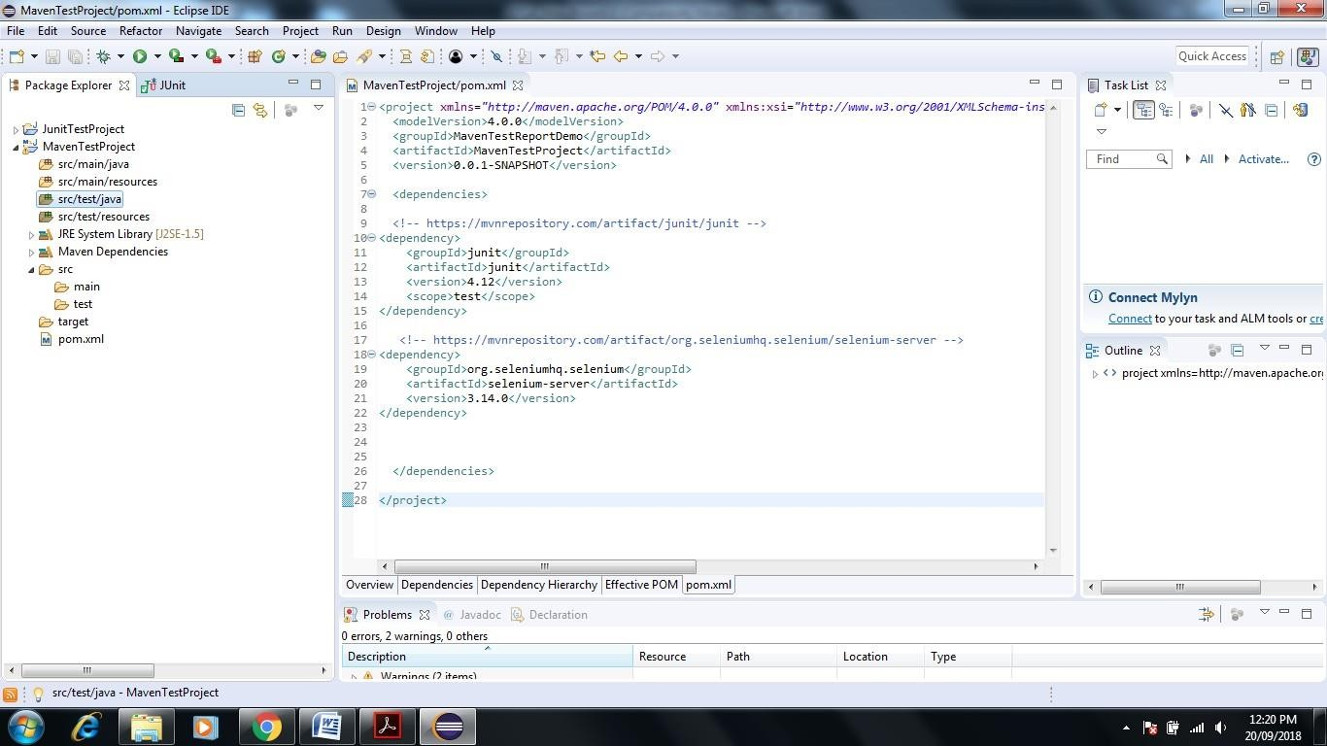**Now go to Eclipse -> Click on Maven Test Project->Right Click on src/test/java**
2. **Click New->Package**

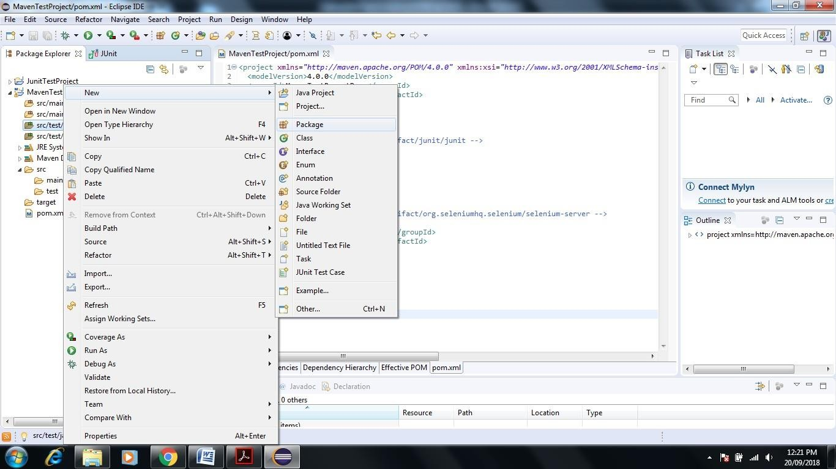

1. 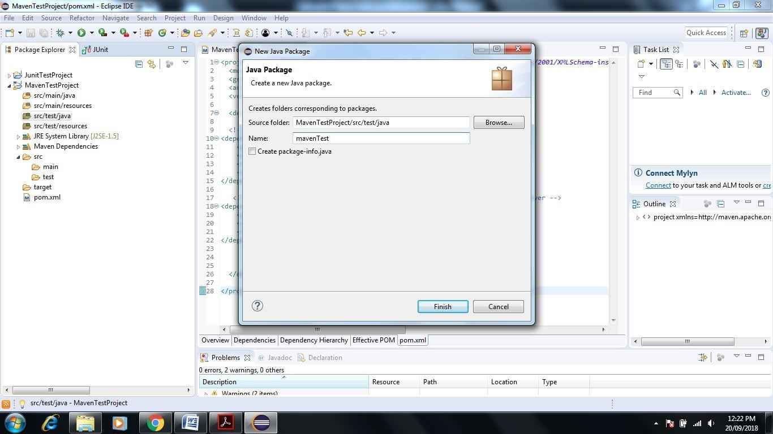**Give name to package mavenTest**
2. **It shows the manvenTest Package under src/test/java folder now rename same by right click on mavenTest Click on Refactor->Rename->give another name com.tem.mavenDemo->Click on ok**

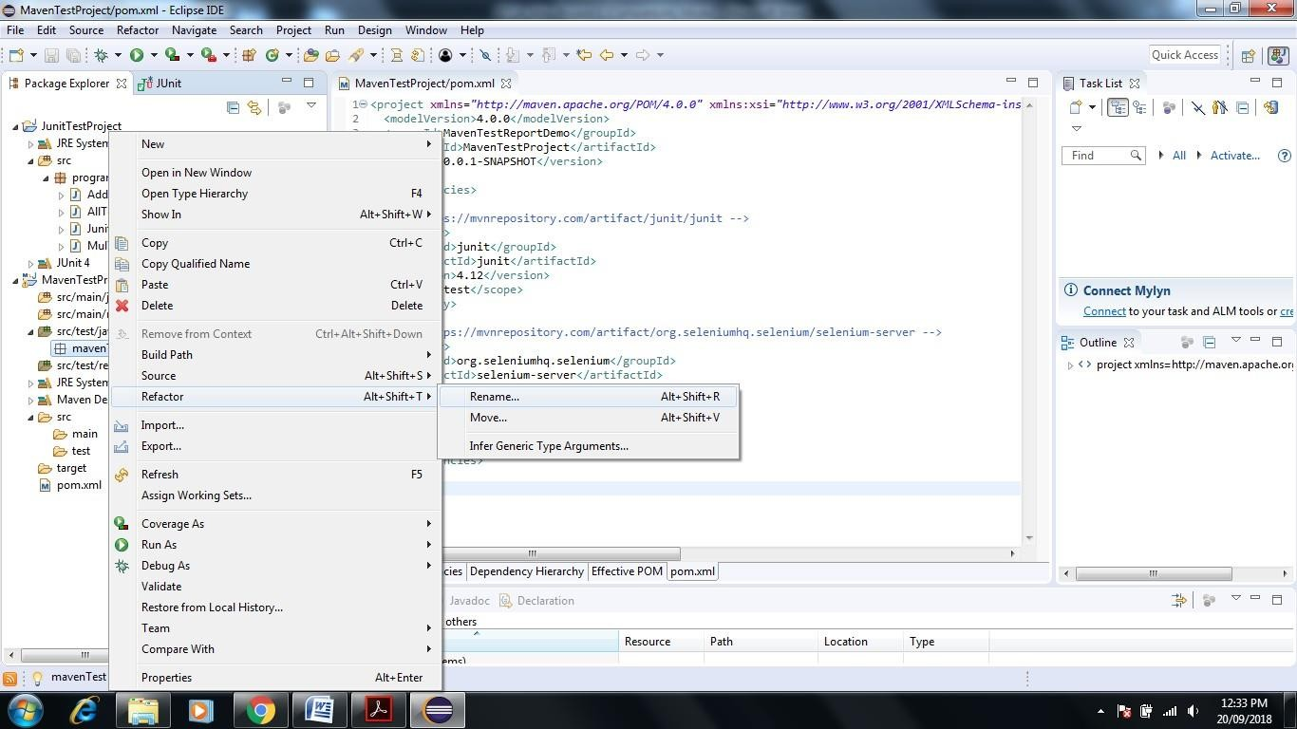

1. **rename as com.tem.mavenDemo**

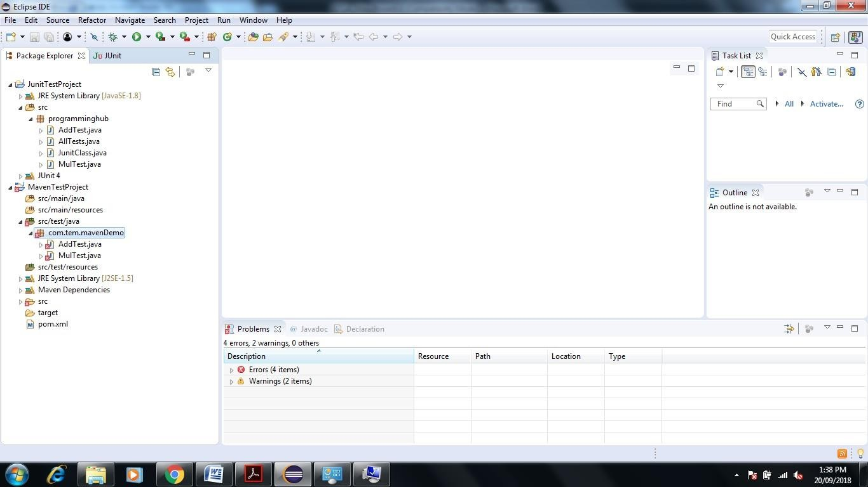

1. **Download Apache Maven Select that binary apache-maven-3.5.4-bin**

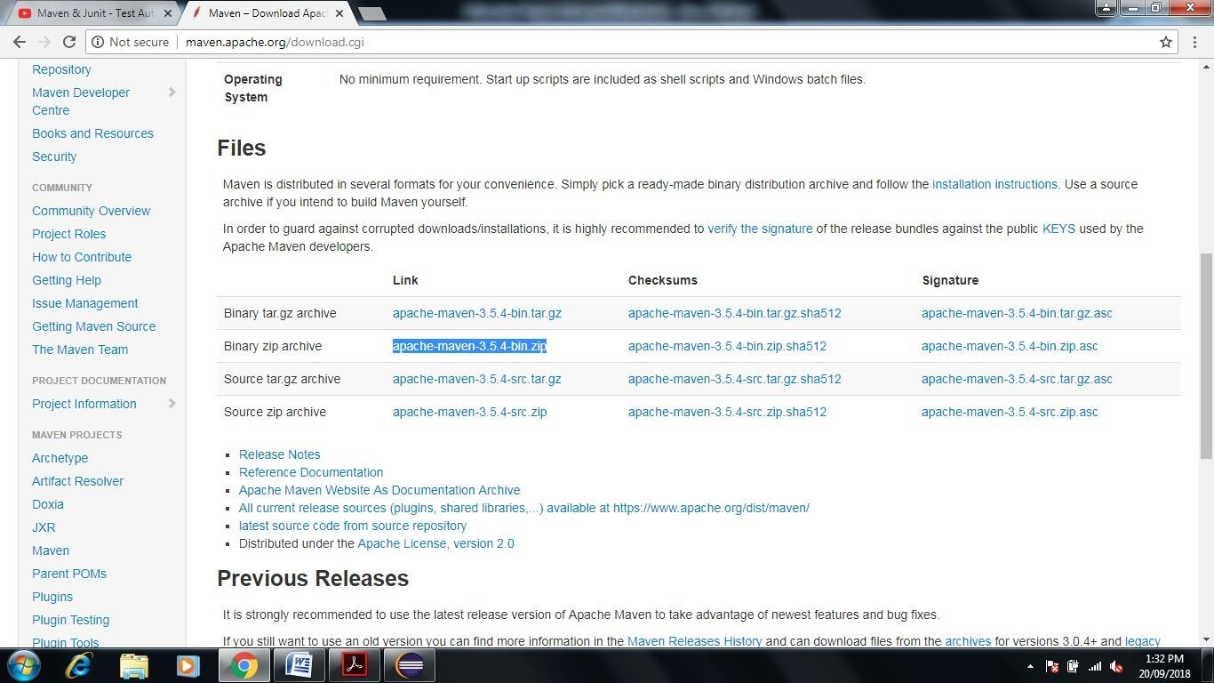

1. **after Download->go to Program File->create one folder give name maven-> now extract the downloaded file in maven folder**

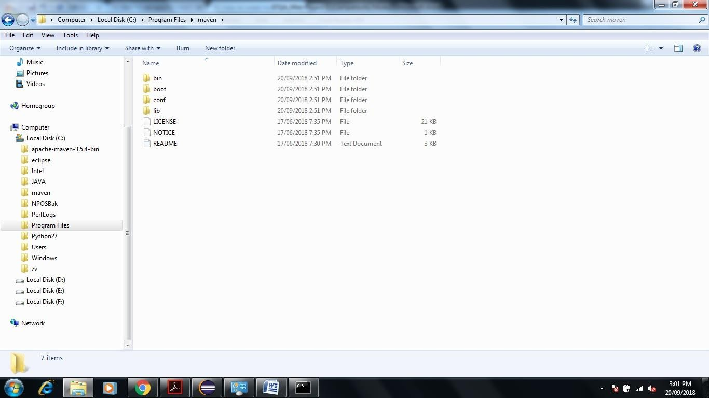

1. **Environment Setup Very Important Steps to Generate Report**
   1. **JDK and JAVA_HOME**

Make sure JDK is installed, and “**JAVA_HOME**” variable is added as Windows environment variable. Our JDK installed in Program File ->JAVA->JDK 1.8.0

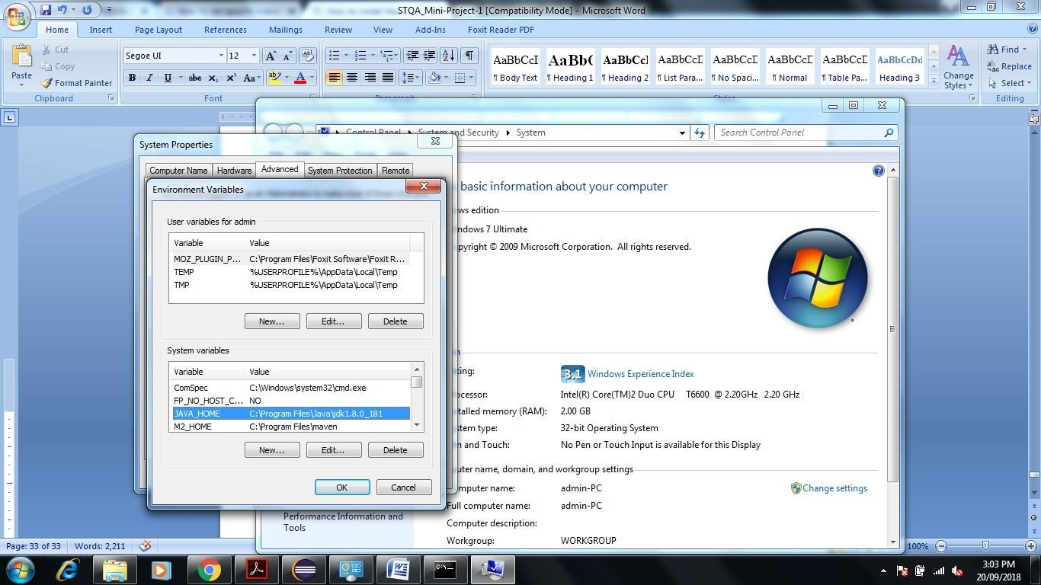

* 1. Set Path of Add **M2_HOME** and **MAVEN_HOME**

**Create new system variable name M2_HOME** and **MAVEN_HOME separately set variable value** **C:\Program Files\maven**

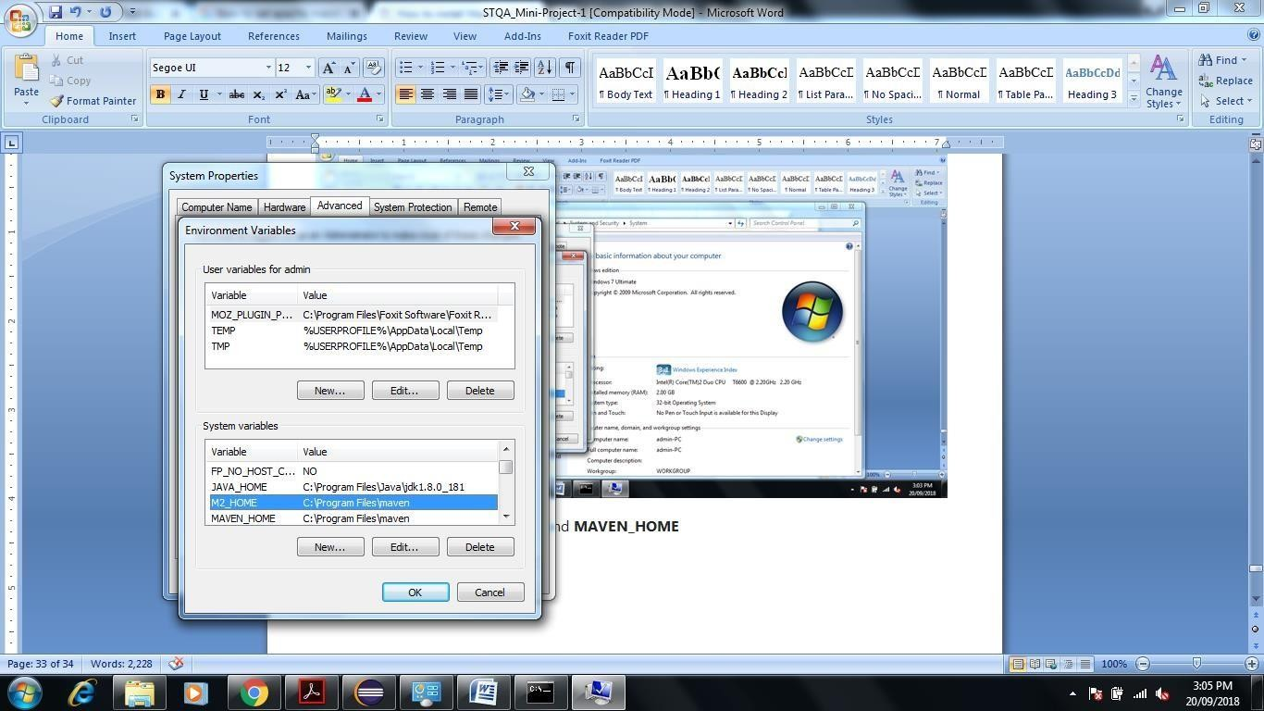

**Figure Shows the Path of M2_HOME & MAVEN_HOME same.**

* 1. **Update PATH Variable as per folowing**

**C:\Program Files\maven%MAVEN_HOME%\bin;%M2_HOME%\bin;**

* 1. **Verification**

**Now copy Previous Created JUnit Test case java file Add Test and Mul Test Paste Externally in E:\MavenTestProject\src\test\java**

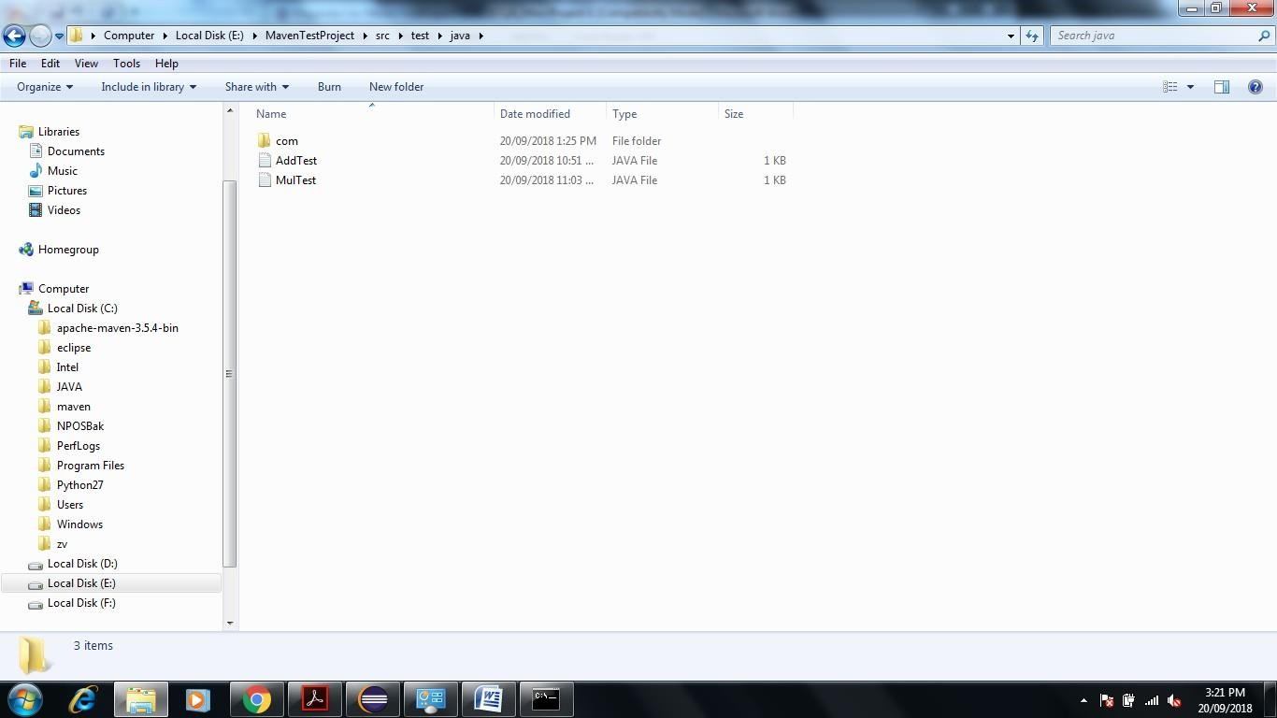

**Now Open Eclipse Right Click on MavenTestProject->Properties****Resources****Copy Pathof Project Folder**

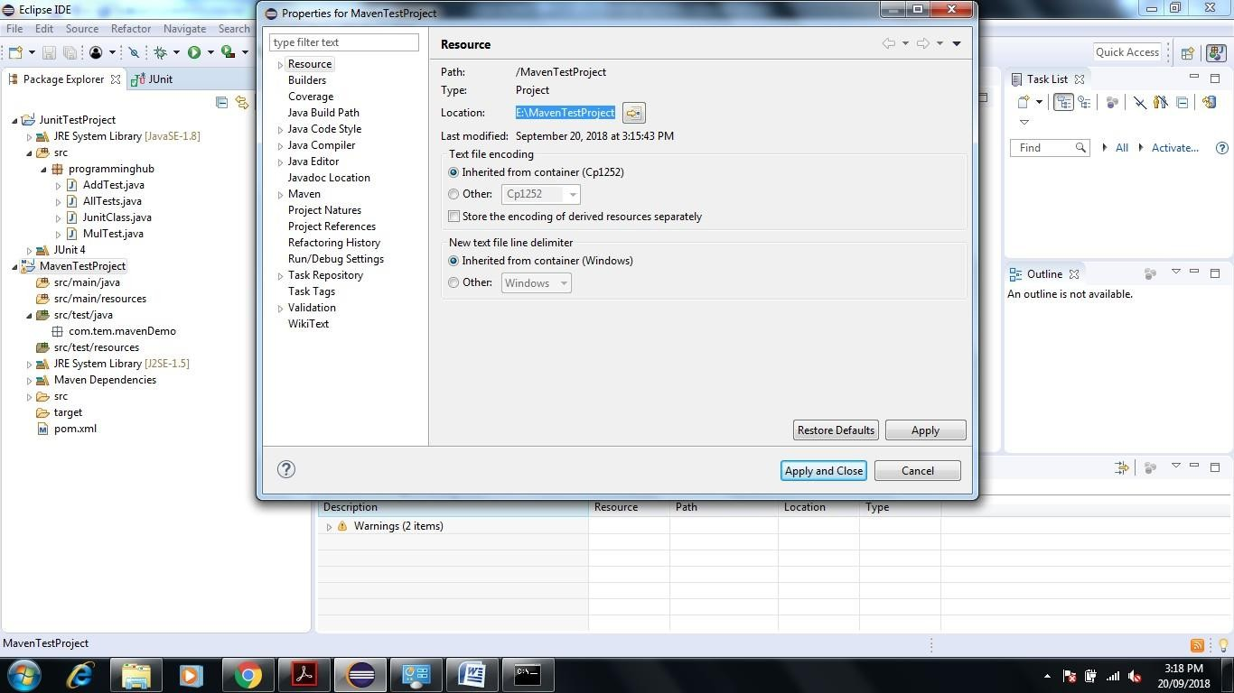

**Now go to command prompt****E:\MavenTestProject>mvn clean**

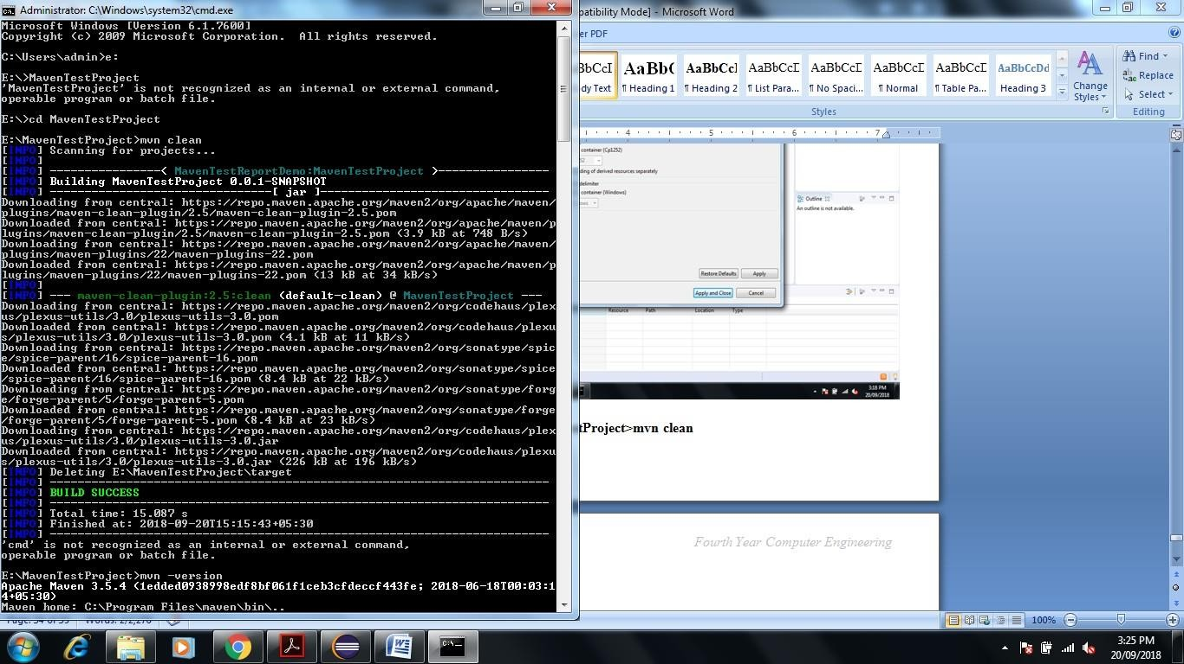

**Enter E:\MavenTestProject>mvn –version**

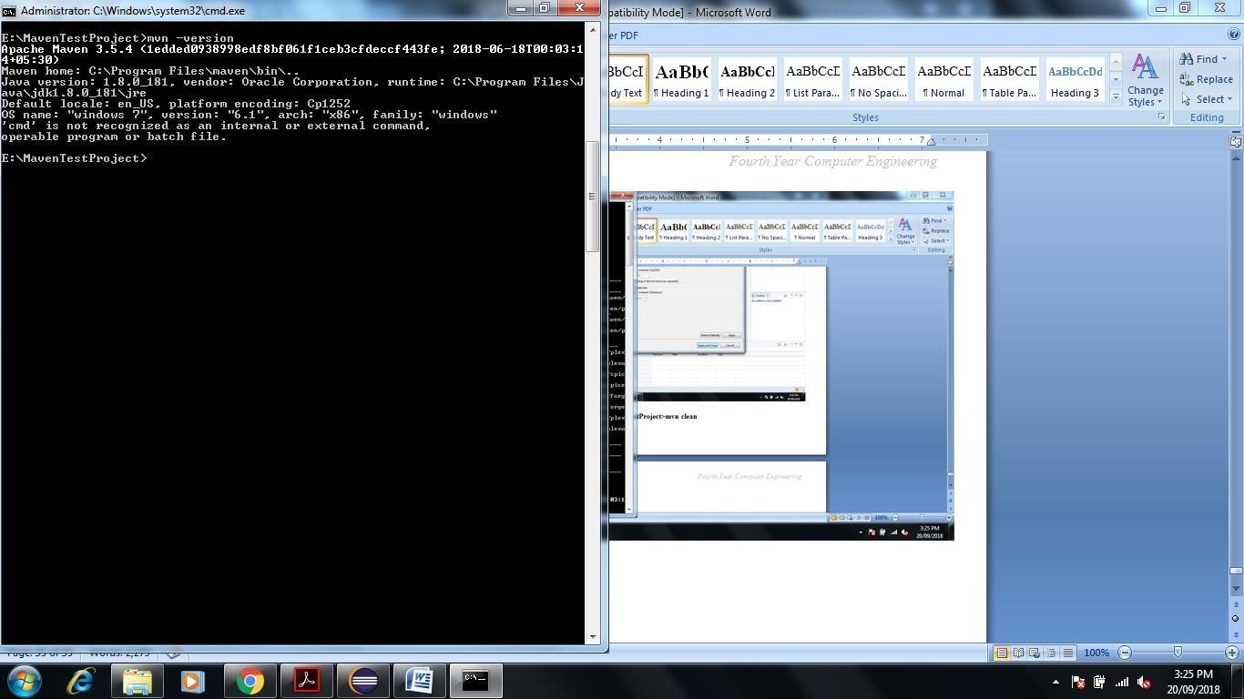

**To run test suite or all test cases under project, give command mvn test**

**Enter E:\MavenTestProject>mvn test**

**This Command is Used to See the Test Report**

**You can even run individual test cases. Give command mvn test –Dtesttestcasename**

**Eg. mvn test –Dtest-AllTest**

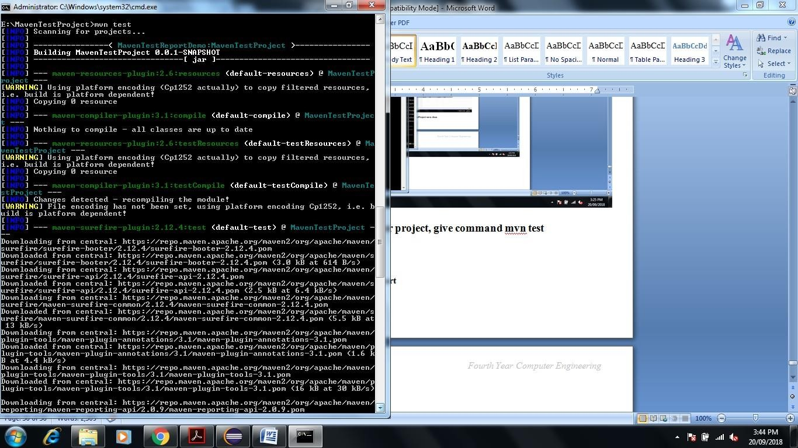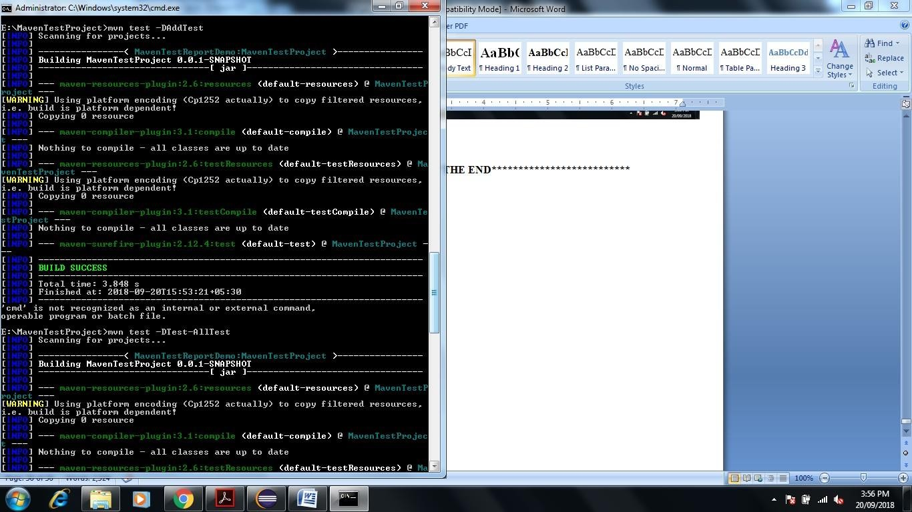

**Conclusion**

In this way using JUnit and Maven Automation tool we are Perform Unit Testing and Prepare Test Report of same.

## Assignment Question

1. Write any Five Tool for White Box and Black Box Testing Purpose.

Input -

import javax.swing.*;

import java.awt.event.*;

import java.awt.*;

public class Hangman implements ActionListener{

public JFrame frame;

public JTextField userInput;

public JLabel textContents;

public JLabel letters;

public JLabel wordselected;

String array = "ant bat cat dog fish goat hen lion monkey ox penguin rat snake tiger whale yak zebra";

String[] split=array.split("\\ ");

int i=(int)(Math.random()*17);

public String word=split[i];

public int correctGuesses;

public int incorrectGuesses;

public String guessesLeft;

public boolean lose = false;

public boolean flag;

public StringBuilder wordsGuessedCorrectly;

Hangman() {

incorrectGuesses = 0;

correctGuesses = 0;

guessesLeft = "You have " + (6 - incorrectGuesses) +" chances left to guess a " + word.length() + " letter word";

wordsGuessedCorrectly = new StringBuilder();

frame = new JFrame("A Hangman Game");

frame.setSize(1380,720);

frame.setDefaultCloseOperation(JFrame.EXIT_ON_CLOSE);

frame.setLayout(new GridLayout(4, 1));

userInput = new JTextField();

userInput.setHorizontalAlignment(JLabel.CENTER);

userInput.addActionListener(this);

frame.add(userInput);

textContents = new JLabel();

textContents.setText(guessesLeft);

textContents.setHorizontalAlignment(JLabel.CENTER);

textContents.setBorder(BorderFactory.createLineBorder(Color.BLUE));

frame.add(textContents);

letters = new JLabel("The letters you guess correctly go down here!");

letters.setHorizontalAlignment(JLabel.CENTER);

letters.setBorder(BorderFactory.createLineBorder(Color.RED));

frame.add(letters);

wordselected =new JLabel("Hint:It is an animal");

wordselected.setHorizontalAlignment(JLabel.CENTER);

frame.add(wordselected);

frame.setVisible(true);

}

String seperateLetter(String a, int x, int y) {

return a.substring(x, y);

}

void testLetter(String a) {

flag=false;

System.out.println(word);

if (word.contains(a) && wordsGuessedCorrectly.toString().contains(a) == false && correctGuesses != (word.length() - 1)) {

correctGuesses++;

wordsGuessedCorrectly.append(a);

letters.setText(wordsGuessedCorrectly.toString());

textContents.setText("Correct Guess!");

flag=true;

}

else if (word.contains(a) && wordsGuessedCorrectly.toString().contains(a)) {

textContents.setText("You've already guessed this letter!");

flag=true;

}

else if (word.contains(a) && wordsGuessedCorrectly.toString().contains(a) == false && correctGuesses == (word.length() - 1)) {

lose = true;

textContents.setText("You Win!");

wordsGuessedCorrectly.append(a);

letters.setText(wordsGuessedCorrectly.toString());

wordselected.setText("You guessed it right, the correct word was "+word);

flag=true;

}

else if (word.contains(a) == false && incorrectGuesses == 5){

textContents.setText("You lose!");

wordselected.setText("Ohh.. hard luck this time, the correct word was "+word);

lose = true;

}

else {

incorrectGuesses++;

textContents.setText("Incorrect Guess! You have " + (6 - incorrectGuesses) + " left.");

}

}

public void actionPerformed(ActionEvent ae) {

if (lose == false) {

String a=userInput.getText();

testLetter(seperateLetter(a, 0 , 1));

userInput.setText("");

}

}

public static void main(String[] args) {

SwingUtilities.invokeLater(new Runnable() {

public void run() {

new Hangman();

}

});

}

}

Test cases -

import static org.junit.Assert.*;

import org.junit.Test;

public class HangmanTest {

Hangman h=new Hangman();

@Test() //To test whether correctGuess variable was initialized properly or not

public void testHangman1() {

if(h.correctGuesses==0) {

System.out.println("correctGuess was initialized successfully to 0");

assertTrue(true);

}

else

{

System.out.println("correctGuess was not intialized properly");

assertTrue(false);

}

}

@Test //To test whether incorrectGuess variable was initialized properly or not

public void testHangman2() {

if(h.incorrectGuesses==0) {

System.out.println("incorrectGuess was initialized successfully to 0");

assertTrue(true);

}

else

{

System.out.println("incorrectGuess was not intialized properly");

assertTrue(false);

}

}

@Test //To test whether userInput frame was initialized properly or not

public void testHangman3() {

if("".equals(h.userInput.getText())) {

System.out.println("userInput frame was initialized successfully");

assertTrue(true);

}

else

{

System.out.println("userInput frames was not intialized properly");

assertTrue(false);

}

}

@Test //To test whether letter frame was initialized properly or not

public void testHangman4() {

if("The letters you guess correctly go down here!".equals(h.letters.getText())) {

System.out.println("Letters frame was initialized successfully");

assertTrue(true);

}

else

{

System.out.println("Letters frame was not intialized properly");

assertTrue(false);

}

}

@Test //To test whether wordselected frame was initialized properly or not

public void testHangman5() {

if("Hint:It is an animal".equals(h.wordselected.getText())) {

System.out.println("wordselected frame was initialized successfully");

assertTrue(true);

}

else

{

System.out.println("wordselected frame was not intialized properly");

assertTrue(false);

}

}

@Test //To test whether SeperateLetter function is working properly for single alphabet or not

public void testSeperateLetter1() {

String a=h.seperateLetter("a", 0, 1);

if("a".equals(a))

{

System.out.println("Seperate Letter is working propely for single alphabet");

assertTrue(true);

}

else

{

System.out.println("Seperate letter is not working properly for single alphabet");

assertTrue(false);

}

}

@Test //To test whether SeperateLetter function is working properly for double alphabet or not

public void testSeperateLetter2() {

String a=h.seperateLetter("bc", 0, 1);

if("b".equals(a))

{

System.out.println("Seperate Letter is working propely for double alphabet");

assertTrue(true);

}

else

{

System.out.println("Seperate letter is not working properly for double alphabet");

assertTrue(false);

}

}

@Test //To test whether SeperateLetter function is working properly for triple alphabet or not

public void testSeperateLetter3() {

String a=h.seperateLetter("cde", 0, 1);

if("c".equals(a))

{

System.out.println("Seperate Letter is working propely for triple alphabet");

assertTrue(true);

}

else

{

System.out.println("Seperate letter is not working properly for triple alphabet");

assertTrue(false);

}

}

}

Output - : 